Analysis of Skeletal Remains - Gender
GENDER
There are several ways to more accurately determine the gender of a skeleton. One of them is by examining the pelvis, which can be identified accurately 95% of the time.
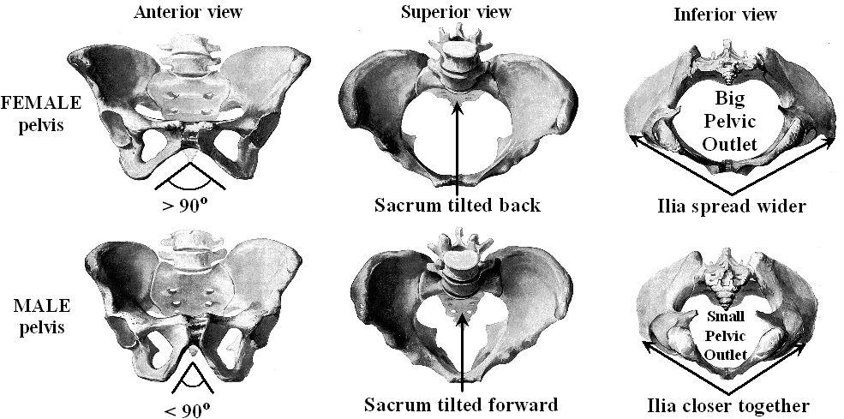
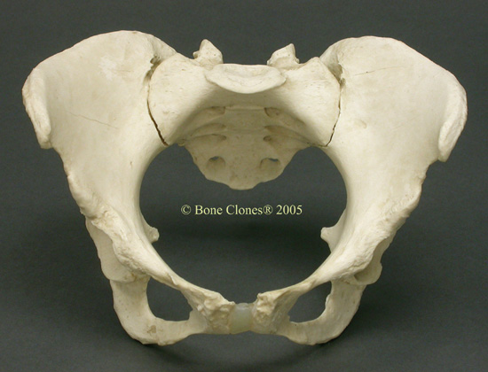 | 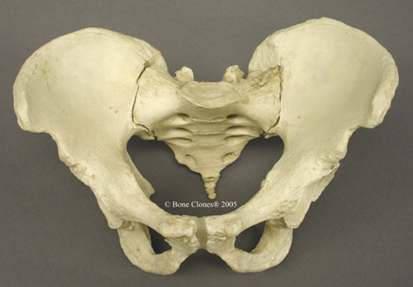
Circle the Appropriate Answer
Angle > 90 degrees or < 90 degrees | Angle > 90 degrees or < 90 degrees
Sacrum Forward or Backward | Sacrum Forward or Backward
Pelvic Outlet Small or Large | Pelvic Outlet Small or Large
Ilia Close or Spread | Ilia Close or Spread
Female or Male | Female or Male

Another way is to examine the skull. This is still fairly accurate, but not as accurate as the pelvis. Forensic anthropologists can accurately identify the skull somewhere between 85 and 90% of the times. This can be complicated by several factors. If a skull is incomplete, then, of course, there is less to work from. Some of the distinguishing characteristics, such as larger bone landmarks for muscle attachments in males, can be easily confused with the landmarks of more athletic females. To put it simply, since the landmarks are often for the attachment of muscles, the larger the muscles, or the more one uses the muscles, the larger the landmarks.
Landmarks | Female | Male
Chin | Rounded | Square
Mastoid Process  (Behind Ear) | Small | Large
External Occipital Protuberance  (Back of Skull) | Small  (Not Prominent) | Large  (Prominent)
General Anatomy | Gracile (i.e., Graceful) | Robust
Forehead | Vertical | Receding  (Careful with the comments . . .)
Brow Ridges  (Location of Eyebrows) | Slightly Developed | Prominent
Muscle Lines | Slightly Developed | Prominent
Orbital Margins  (Edge of Eye Socket) | Sharp | Rounded
Angle of Ascending Ramus  (Back Corner of the Jaw) | Obtuse | Close to 90 degrees
Now try to identify the skulls below by gender:

Another way is to examine the skull. This is still fairly accurate, but not as accurate as the pelvis. Forensic anthropologists can accurately identify the skull somewhere between 85 and 90% of the times.

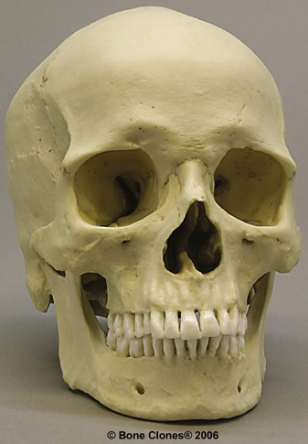 | 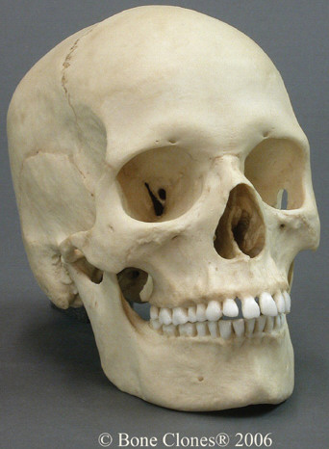
Circle the Appropriate Answer
Chin Rounded or Square | Chin Rounded or Square
Occipital Protuberance Small or Large  (back of skull) | Occipital Protuberance Small or Large  (back of skull)
General Anatomy Gracile or Robust | General Anatomy Gracile or Robust
Forehead Vertical or Receding | Forehead Vertical or Receding
Brow Ridges Slight or Prominent  (location of eyebrows) | Brow Ridges Slight or Prominent  (location of eyebrows)
Orbital Margins Sharp or Rounded  (edge of eye socket) | Orbital Margins Sharp or Rounded  (edge of eye socket)
Angle of Ramus 90 degrees or Obtuse  (back corner of jaw) | Angle of Ramus 90 degrees or Obtuse  (back corner of jaw)
Gender Female or Male | Gender Female or Male

Now that you have had some practice, what about this lone skull?
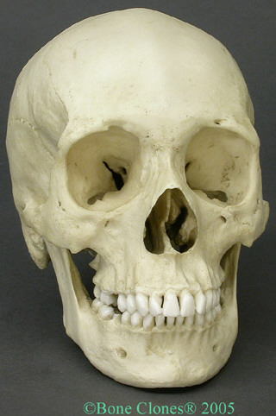 | Circle the Appropriate Answer  Chin Rounded or Square  Mastoid Process Small or Large  Occipital Protuberance Small or Large  General Anatomy Gracile or Robust  Forehead Vertical or Receding  Brow Ridges Slight or Prominent  Muscle Lines Slight or Prominent  Orbital Margins Sharp or Rounded  Angle of Ramus 90 degrees or Obtuse  Gender Female or Male
Original image from http://www.boneclones.com

