Andrew Coyne: It's not the governor general's fault, the Liberals are to blame
Payette's appointment is in many ways typical of the Trudeau Liberals, in its devotion to style over substance, to ticking identity boxes over fitness for the job
It all rather has the sense of a dam having burst. In recent days a spate of stories has appeared in the nation’s media, notably the National Post’s weekend magnum opus, describing the many ways in which the current Governor General of Canada, Julie Payette, is said to be failing to do her job.
Official Ottawa has been privately seething for months with tales of her high-handed style and selective approach to her duties. Now they are all out in the open: of the sluggish pace of her public appearances; of the charities and non-profits left in limbo by her demands for an unspecified “review” of their patronage; claims of her contempt for either the dictates of convention or the limits of her role, including attempts to intrude in areas a governor general really should not intrude into, from government policy to the honours system; claims that she initially refused to participate in a ceremony giving royal assent to a government bill because it meant a change in her schedule.
Perhaps you are reading this thinking: well, so what? So she doesn’t like making small talk at official functions — who does? So she pushes back when decisions are pressed upon her — who wants to be just a rubber stamp? So she blows off some dusty old conventions — like a breath of fresh air, you mean? And all of this would be perfectly reasonable, admirable even, in any office but that of Governor General of Canada.
The job description of a governor general would read something like: must like crowds and parties; must have a deep respect for custom, tradition and convention, together with a profound understanding of the constitutional role of the Crown in our Parliamentary system; must take instruction well.
The last is perhaps the most important. Doing what you are told is not just an incidental part of a governor general’s vocation: it is at the very core of it. A modern constitutional monarch has many roles, but among them is to be a living symbol of the taming of the Crown, from all-powerful autocrat to deferential servant of democracy. You are given the Speech from the Throne to read, you bloody well read it as written.
So among the qualities desirable in a governor general, as the Queen’s representative in Canada, a certain humility would be foremost. In this, as in other respects, Payette would seem peculiarly unsuited for the position she now holds, whatever her other accomplishments in life. She gives every appearance of believing that it is she who ennobles the office, rather than the other way around.
Yes but: does the office itself matter? This will be the other common response. Isn’t this a lot of fuss over nothing? Isn’t the whole monarchy thing just a preposterous game of dress-up, the governor general an embarrassing colonial relic?
There isn’t space here to rehearse the broader case for the Crown: its foundational role in our system of laws and government; the virtues, so evident in light of events south of the border, of separating the head of state and the head of government, that the temporary occupants of elected office might be discouraged from getting above themselves; the humanizing symbolism of placing at the apex of our society, not some dry abstraction or totalizing idea, but a family, like any other.
The governor general’s office said Friday Payette is committed to serving Canadians and that she has fulfilled her duties. The criticisms of her are “either inaccurate or based on incomplete information.”
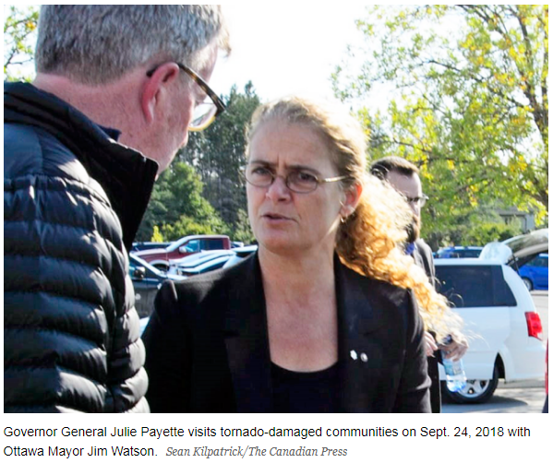
For now I would simply say: tell it to the people of Humboldt, Sask., who will not receive a visit from the governor general until next month, six months after the highway accident that nearly wiped out their local hockey team. One function of the Crown, classically, is as the “fount of honour.” That’s true in the literal sense, that official honours and titles are awarded in its name. But it is also true in a more figurative sense. Where the Queen turns her attention, she turns the attention of the public. Her role, like that of her representatives, is to focus and direct the feelings of the entire nation.
When the governor general shows up in a place like Humboldt, with all of the attendant publicity, she does not represent only herself or her office or even the Queen: she represents all of us, and the honour and recognition and love she brings to the people of Humboldt in such times concentrates that of 37 million Canadians. Mostly it says, we are paying attention — we are aware of your grief, and it matters to us, because you matter to us. As the failure of the governor general to show up can only convey the opposite.
But the fault for this fiasco does not lie with Payette, who is who she is, but with the government that saw fit to appoint her. The appointment is in many ways typical of the Trudeau Liberals, in its devotion to style over substance, to ticking identity boxes — a woman, young, francophone, etc. — over fitness for the job. (“She is perfectly aligned with the image we want to project,” a senior Liberal sighed contentedly at the time.)
Not only did the Prime Minister’s Office fail to consult the experts on the previous government’s Advisory Committee on Vice-Regal Appointments, but it also ignored the advice of its own Privy Council. Its vetting process — entrusted to the renowned Liberal Research Bureau — somehow failed to unearth such gems from her past as a charge of assaulting her ex-husband: expunged, certainly, but surely relevant in considering her suitability for the highest office in the land.
For in the end the choice of governor general is an expression of what we value as a society. The appointee, after all, is required not only to represent the nation but to unify it in times of crisis — the job demands, on occasion, nothing less than choosing a government. Were we a serious country, we would reserve such a position to persons of enormous gravitas: men and women of immense moral standing in the community, who had consistently demonstrated superior integrity and judgment in positions of great responsibility, figures of universal respect and even reverence.
But as we are a deeply unserious country, we deny that gravitas matters, or that some could be in greater possession of it than others. The consequences confront us.

