Name:
Arab-Israeli Conflict
References:
Global Forces, Chapter 12 (p. 213-231)
Student Workbook (p. 59-62; p.164-172)
Class Notes/ Slide show – campbellswebsoup.weebly.com
Summary Notes Handout

Map Assignment
Label:
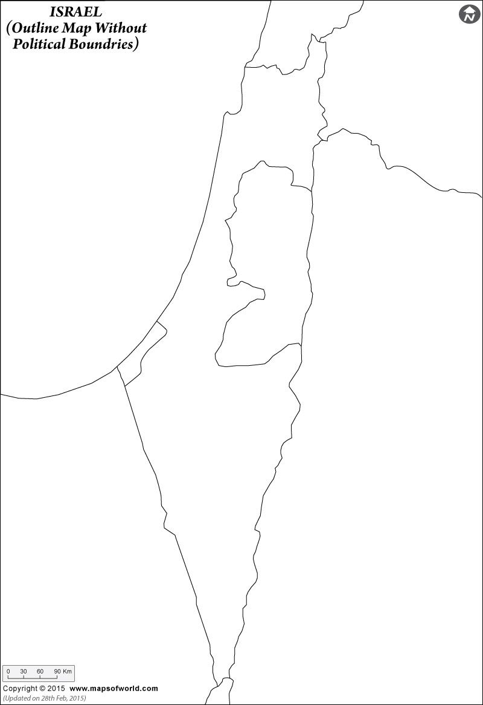
- Israel
- Egypt
- Jordan
- Lebanon
- Syria

- Jerusalem

- Golan Heights
- Gaza Strip
- West Bank
- Sinai Desert

Define:
Zionism

Jewish Diaspora

Anti-Semitism

Questions:
- In 1916, 1917 and 1918, the British made three contradictory promises regarding the territory of Palestine. Identify and explain these contradictory promises Britain made to Arabs and Jews in regards to Palestine.

- Define the ‘Mandate System.’ Why might it have been viewed by Palestinians as ‘New Imperialism?’

Read the following excerpts:

According to the Covenant of the League of Nations 1919 – Article 22 states (an ideal?):

‘Certain communities formerly belonging to the Turkish (Ottoman) Empire have reached a stage of development where their existence as independent nations can be provisionally recognized subject to the rendering of administrative advice and assistance by a Mandatory until such time as they are able to stand alone. The wishes of these communities must be a principal of consideration in the selection of the Mandatory.’

According to the Palestinian Mandate – 1922 (the reality?):

‘Whereas the Principled Allied Powers have also agreed that the Mandatory should be responsible for putting into effect the declaration originally made on November 2nd, 1917, by the Government of His Britannic Majesty, and adopted by the said Powers, in favor of the establishment in Palestine of a national homes for the Jewish people….Whereas recognition has thereby been given to the historical connection of the Jewish people with Palestine and to the grounds for reconstitution their national home in that country….The Mandatory shall have full power of legislation and of administration.’

- Given that the population of Palestine was 95% Arab (not Jewish) at the end of WWI, refer to the two excerpts above and determine how the Palestinian Mandate contradicts some of the terms laid out in Article 22.

- Explain why the British turned to the United Nations to solve the problems of Palestine and what the UN decided to do about it. Also, what was the response by Jews and Arabs to the UN compromise?

- The UN’s Partition Plan was ultimately decided on the battlefield – the Arab-Israeli War (1948). What immediate impact did the creation of the state of Israel have on the Palestinians. How would this prove to be problematic for Israeli-Palestinian relations in future (and among Arab nations)?

- Fill in the details required for each of the following conflicts in the Arab-Israeli conflict (next page):
*Note: there are no simple answers in defining ‘aggressors,’ for point of view must be considered – try and understand the conflict from a neutral position and explain as objectively as one can. If you considered one side the aggressor, consider also how they might feel as ‘victims.’

 | Palestinian War/Arab-Israeli War, 1948 | Suez War, 1956
Key Players
- Nations
- Leaders

- Causes

Aggressor(s)*
- Explain

Results
- Territorial

Significance

 | Six Day War, 1967 | Yom Kippur War, 1973
Key Players
- Nations
- Leaders

- Causes

Aggressor(s)*
- Explain

Results
- Territorial

Significance

- In assessing the Arab-Israeli Wars from 1948 to 1973, militarily, what nation succeeds time and time again?
- Critical Analysis: Explain how the establishment of the state of Israel has destabilized the Middle East.

- How did the Yom Kippur War affect the industrial nations of the world? What did the USA do in response?

Camp David Accord
- How did the Camp David peace accords attempt to solve the problem of the Middle East?

Read the following excerpts:
The Security Council,
Expressing its continuing concern with the grave situation in the Middle East….

Affirms that … the establishment of a just and lasting peace in the Middle East … should include the application of both the following principles:

- Withdrawal of Israeli armed forces from territories occupied in the recent conflict;

- Termination of all claims or states of belligerency and respect for and acknowledgement of the sovereignty, territorial integrity and political independence of every State in the area and their right to live in peace within secure and recognized boundaries free from threats or acts of force;

Affirms further the necessity… [of] achieving a just settlement of the refugee problem; [of] guaranteeing the territorial inviolability and political independence of every State in the area….

United Nations Security Council Resolution 242
22 November, 1967

The parties are determined to reach a just, comprehensive, and durable settlement of the Middle East conflict through the conclusion of peace treaties based on Security Council resolutions 242 and 338 in all their parts.
…
Egypt and Israel agree that… there should be transitional arrangements for the West Bank and Gaza for a period not exceeding five years. In order to provide full autonomy to the inhabitants, under these arrangements the Israeli military government and its civilian administration will be withdrawn as soon as a self-governing authority has been freely elected by the inhabitants of these areas… A withdrawal of Israeli armed forces will take place… The agreement will also include arrangements for assuring internal and external security and public order.
…
[T]he Palestinians will participate in the determination of their own future through:
- The negotiations among Egypt, Israel, Jordan and the representatives of the inhabitants of the West Bank and Gaza to agree on the final status of the West Bank and Gaza.
- Submitting their agreements to a vote by the elected representatives of the inhabitants of West Bank and Gaza… to decide how they shall govern themselves.

Signed by: Muhammed Anwar as-Sadat, Menachem Begin, Jimmy Carter
Camp David Accords, 17 September,1978

- How does the agreement between Sadat (Egypt), Begin (Israel) and Carter (USA) at Camp David substantiate the core principles behind the United Nations Security Council Resolution 242? Explain.

Read the following excerpt and refer back to the excerpt outline the terms of the Camp David Accords:
Concerning Judea, Samaria [i.e., the West Bank] and the Gaza District:

We have signed a very serious agreement. Now, on the basis of our peace plan, the agreement says that the Palestinian Arabs residing in Judea, Samaria [the West Bank] and the Gaza District will have autonomy. Full autonomy. They will themselves select their administrative council… and deal themselves with the daily affairs of their lives. We shall not interfere [according to the plan]. They will have self-rule, as we believe it is just that they should have. And we, the Jews, will have security. As we believe it is indispensable justice that they should have it.

As a result, I hereby declare, that the Israeli Defence Forces will stay in Judea, Samaria [the West Bank] and the Gaza District to defend our people and to make sure that Jewish blood is not shed again by our implacable enemies. [APPLAUSE]

And if anybody made a declaration to the effect that the agreement means that our Defence Forces will stay in Judea, Samaria [the West Bank] and the Gaza District only for 5 years, I hereby declare they will stay beyond 5 years.
…
Yes, Judea, Samaria [the West Bank] and the Gaza Strip are integral parts of Greater Israel, land of our forefathers, which we have never forgotten during exile, when we were a persecuted minority, humiliated, killed, our blood shed, burned alive. We always remembered Zion, and Zion means Greater Israel. It is our land as of right.

Menachem Begin, Prime Minister of Israel, in a speech to about 2,000 American Jewish leaders in the American Hotel, New York City, three days after the signing of the Camp David Accords, 20 September, 1978.

- To what extent did Menachem Begin in his speech (above) presenting the Camp David Accords, accept the terms of the accord?

Read the following two excerpts:
Consider what is universally called the "peace process" in the Middle East, referring to the Camp David agreements. Israeli-run polls reveal that the population of the territories under Israeli military occupation [the vast majority of whom are Arab Palestinians] overwhelmingly oppose the "peace process", regarding it as detrimental to their interests. Why should this be so? Surely of all the people in the region, they are among those who must be yearning the most for peace. [This is a] strange paradox.

The problem [of understanding this paradox] is easily solved. The "peace process", as was evident at the time [of the Camp David Accords] and should be transparent in retrospect, was designed… to remove the major Arab military force, Egypt, from the conflict, so that Israel would then be free, with a huge and rapidly-expanding U.S. subsidy, to intensify settlement and repression in the conquered territories…. It is hardly a cause for wonder that the victims of the "peace process" [i.e., the Arab Palestinians] overwhelmingly condemn and reject it….

Noam Chomsky, "The Manufacture of Consent," (1984) in The Chomsky Reader, New York: Pantheon Books, 1987, pg. 134.

The key element that underlies the [Israeli-Palestinian] conflict, that gives energy and credibility to its extremist edges, is what is called "the occupation". This is pretty straightforward. Some 230,000 Israeli settlers (400,000 counting those in Greater Jerusalem) sit on land occupied by the Israeli military during the Six Day War, back in 1967. This small population controls a disproportionate share of the best land and vital water resources. In Gaza for example, some 7,000 settlers control 20 percent of the land, leaving a million-odd Palestinians crowded into the rest.
…
To protect the settlements the Israelis have built up a formidable military structure of road blocks, army bases, border controls, secret police surveillance, aerial patrols, 300 miles of US-financed, Israeli-only, by-pass roads. It splits Palestinian territory into some 22 separate "Bantustans". You can't move in any direction from any major Palestinian population centre without having to pass through at least one Israeli checkpoint. For Palestinians this is demeaning, time-consuming and often dangerous. In times not dominated by tanks and helicopter gunships the checkpoints is the very essence of occupation. The cost to the Palestinian economy is staggering. In Bethlehem [in the Occupied Territories] you sometimes can't get fresh vegetables for love or money, while not many miles away in Jericho they rot for a lack of a market.

Richard Swift, "Israel and Palestine: The Occupation is Killing Us All", in The New Internationalist, August, 2002.

- According to Noam Chomsky's interpretation, why would the "occupation" of the West Bank and the Gaza Strip, described by Richard Swift, have been made easier for the Israelis to continue after the Camp David Accords?

- To what extent was the Camp David Accords successful in achieving peace in the Middle East? Where has it been successful? Where has it failed (so far as bringing peace to the region, especially in regards to Palestine)?

- Yasser Arafat, a controversial figure of the Middle East, is seen as ‘freedom fighter’ and ‘terrorist.’ Explain.

- The Oslo Accords were a landmark agreement, however, in the 25 years since their signing, the peace process has stalled. Explain what followed Oslo and some of the problems in attaining a lasting peace for Israelis and Palestinians in the Middle East.

