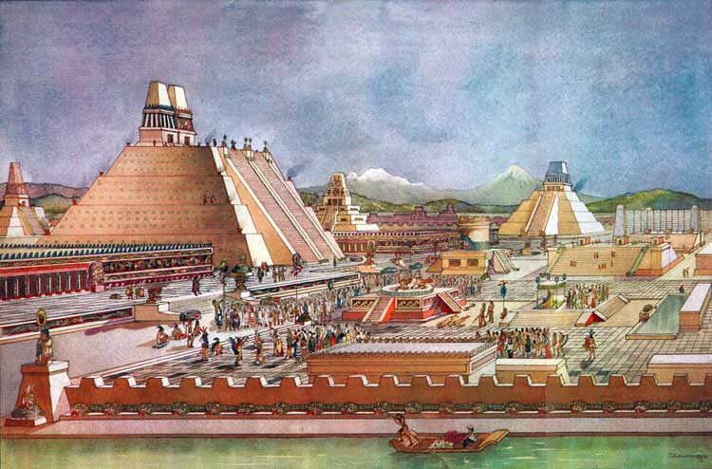
Name:
The Ancient Aztecs
Reference: DeGeer & Newman, Odyssey Through the Ages, 1992

Questions
1. Describe the climate and geography of the Valley of Mexico. Explain how it held great agricultural promise despite environmental challenges and explain what the Aztecs did to make the land productive.

2. What made areas outside the Valley of Mexico prime targets for Aztec expansion and conquest?

3. What does the story (the legend) of the Aztec migrations and their eventual conquest of central Mexico tell us about these people?

4. The Aztecs are aid to be a people of contradiction. Explain why by briefly commenting on their beliefs and view of the world.

5. Explain why humans were sacrificed by the Aztecs and comment on the significance of human sacrifice to their religion.

6. The apparent ‘bloodthirsty’ nature of the Aztecs was largely the work of one man. Explain.

7. Explain how the education and upbringing of Aztec boys and girls differed.

8. Summarize the information for each of the Aztec classes in society

 | Clothing | Homes | Econ. Resources | Role in Society
Ruler
Chiefs
Nobles
Merchants
Artisans
Commoners
Slaves

9. Art is often a reflection of the society which produced it. What does Aztec art (sculpture, painting, writing) tell us about Aztec life?

10. How does the concept of time and history different from the May?

11. List and describe the various foods which were important in the diet of the Aztecs.

12. Throughout this chapter there are numerous quotations taken from Spanish reports. Is there an obvious sense that the Spanish perceived the Aztecs as different? Inferior? Civilized or uncivilized? Provide specific examples.

