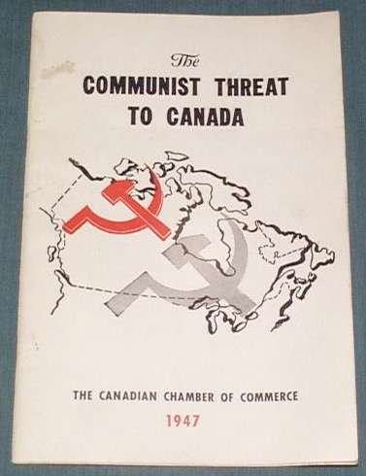
Name:
Social Studies 11
Canada and the Cold War
Focus Questions:
- What was Canada’s involvement in the Cold War?

Main Reference: Cranny, M., Moles, G. (2010). Counterpoints: Exploring Canadian Issues. Toronto: Pearson.

Reading: Ch. 6 p. 190-203 (try a quick read thru first)

Questions:

Core Ideas – Provide a brief definition and/or example for the following terms and ideas:

- Understand the difference between ‘communist’ and ‘capitalist’ societies

- Which were the ‘superpowers’ of the Cold War? Why not others?

1. What was the basic reason(s) for the Cold War?

2. How did the Cold War affect Canada?

3. What is NATO? What was the Warsaw Pact? What was their purpose?

4. What is NORAD and how was Canada involved in North American Defence?

5. Why was the United Nations formed and how has Canada played a role in the UN?

6. What was the Korean War about and what was Canada’s role?

7. What were the main issues of the ‘Suez Crisis’ and how did Canada ‘save the day?’

8. What was the Colombo Plan and what was Canada’s role?

Read and think about the ‘Red Menace’ (p. 192-193):
Is banning certain social, political or economic groups ever justified? Explain.

