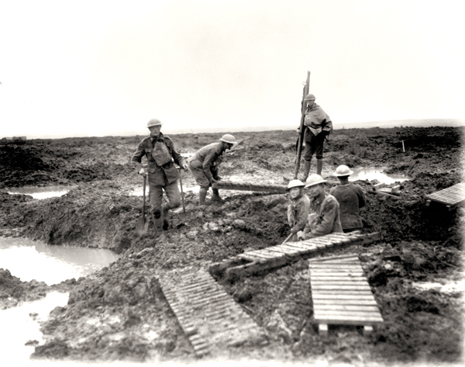
Name:
Social Studies 11 World War One
Canada Enters WWI
Focus Questions:
- How did Canada respond to the outbreak of war in Europe?
- What effect did Canada’s participation in WWI have on Canadian society and its status as a nation?
- What did Canada contribute to the war effort in Europe? What was the result?

Reference:
Counterpoints: Exploring Canadian Issues (2010), p. 32-44.

Define the following terms and ideas:

mobilization

War Measures Act

internment camp

Western Front

war of attrition

Questions
1. What was Borden’s troop commitment? (p. 32)

2. What was the reaction by Canadians? (p. 32)

3. What was the role for women? (p. 32)

4. Were all welcome in the army? (p.32)

5. What happened at Valcartier, Quebec? (p. 33)

6. What types of ‘propaganda’ (strongly biased advertising) did Canada use during WWI to support the war effort? (p. 33)

7. What is Sam Hughes remembered for? (p. 34)

8. What did the War Measures Act allow? (p. 34)

9. How did Germany plan to invade France? Did it work?

10. Describe briefly what trench warfare involved and how technology played a role in the war. (p. 36 & powerpoint)

Canada’s Sacrifice – use your textbook (and other sources) to help complete this chart.

Battle | Interesting Details | Canada’s Role
2nd Battle of Ypres  p. # in text:  # on map:  Date: | • First actions seen by CEF | • ____________ Canadian casualties
Battle of the Somme  p. # in text  # on map:  Date: | • Commander: Douglas Haig  • Called the ‘Bloodbath’ | • _____________ Canadian casualties  • 90% of Royal Newfoundland  Regiment suffered casualties  from German machine guns

Battle | Interesting Details | Canada’s Role
Battle of Vimy Ridge  p. # in text:  # on map:  Date: | • strategic location held by Germans  • efficient planning and training  contributed to victory by Canadians  • most significant victory of the war up  to that date | • _____________ Canadian lives lost
Passchendaele  (3rd Battle of Ypres)  p. # in text:  # on map  Date: | • mud was so bad men drowned in it  • poorly organized  • nearly ½ million soldiers killed | • _____________ Canadian lives lost

Find out about the following:

War in the Air (p.42)

War at Sea (p. 44)

Define the following terms:

casualties

reconnaissance

merchant marine

convoy

