Canadian Identity and the things that define us

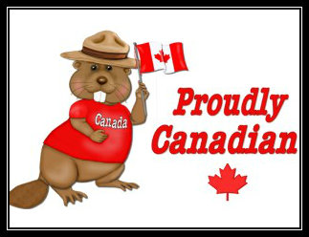
I AM CANADIAN: THE RANT

Hey, I’m not a lumberjack, or a Fur trader.
I don’t live in an igloo,
Or eat blubber
Or own a dogsled.
And I don’t know Jimmy, Sally or Suzy from Canada,
Although I’m certain they’re really, really nice.

I have a prime minister…not a president,
I speak English and French, not American
And I pronounce it About, not A-boot.

I can proudly sew my country’s flag on my backpack,
I believe in peacekeeping, not policing, diversity not assimilation, and that the beaver is a truly proud and noble animal.
What do you think?

Are these just stereotypes?

Does this represent how most Canadians define themselves?

If not, how do they?
A toque is a hat,
a chesterfield is a couch,
and its pronounced Zed,
not Zee…Zed!!
Canada is the 2nd largest land mass,
The 1st nation of hockey,
And the best part of North America.

My name is Joe….
And I am Canadian!

Introductory Activity
Listen to the Joe Canadian ‘Molson Rant’ -
https://www.youtube.com/watch?v=WMxGVfk09lU

Also, check out Shane Koyczan’s ‘We are More’ (performed during the 2010 Olympics)
https://www.youtube.com/watch?v=r5-q6S8qJMQ
and an extended version of ‘We are More’
https://www.youtube.com/watch?v=Pq_xddkO064

Finally, check out this news article on ‘Canadian Identity’
http://news.nationalpost.com/2012/12/28/year-in-ideas-how-canadian-identity-has-changed-and-what-it-means-for-our-future/

Task 1: Jot down your ideas:
1. What do you think it means to be Canadian?

2. What is so special about Canada? What sets us apart from other nations?

3. Are their ‘Canadian’ beliefs or values?

4. Are things about Canada or ‘being Canadian’ that are not good and need to change?

5. Is it fair to talk about one Canada? Is it really one thing? (how important is nationality?)

Task 2: Selling Canada
You are on vacation in another country (you choose) and you make friends with someone who is interested in moving to Canada. They ask you to tell them what Canada is all about and what they should expect. What do you say?

