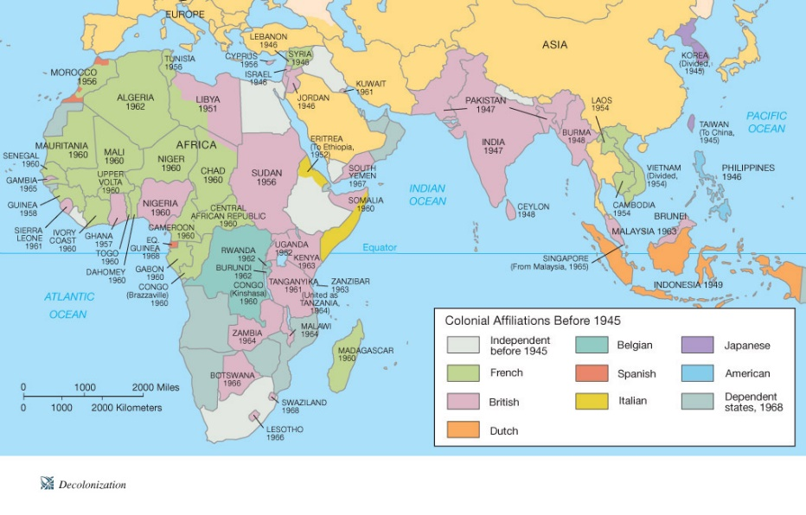
Decolonization
Nationalist movements swept across the African and Asian continents following the Second World War. Nations unburdened themselves of their colonial masters, though the legacy of colonialism would be harder still to overcome. There was no one process of decolonization. In some areas it was peaceful and orderly and in others it was only achieved after a prtoracted and violent conflict (and then some in between).

References:
Campbell’s Website – www.campbellswebsoup.weebly - See slide show – ‘Decolonization’
  - this resource has embedded in it, links to internet resources that will be helpful to students in answering the questions on this handout – please review carefully.
  - You may find reviewing other more fruitful interweb sites helpful too….
Student Workbook
South Africa – p. 209-211 Indian Independence – p. 59-60; 155-156
Map History of the World Textbook – assorted sectional pages for good background and context

Define
Imperialism

Colony

Self-Determination

Ethnocentrism

Scramble for Africa

Nationalism

Questions
1. Discuss the implications of the Berlin Conference (1885) for both Europe and Africa.

2. The Congo is a case study for how European colonialism oppressed Africa and Africans. Discuss.

3. Why were European nations more willing to relinquish (albeit, slowly…) colonies in Africa post-WWII?

4. In what ways did colonies achieve independence from their colonial masters? Explain.

Read: The Dividing of a Continent – and answer the following three questions.
5. How are political borders in Africa different from other continents, like Europe, for example? Explain.

6. The political borders in Africa were drawn up by European colonizers. Why haven’t African leaders redrawn those boundaries to better reflect linguistic and ethnic realities in Africa?

7. Identify and explain three instances where boundaries have or potentially could create problems for nations in Africa.

Review the map of Africa’s decolonization below to answer the questions that follow:
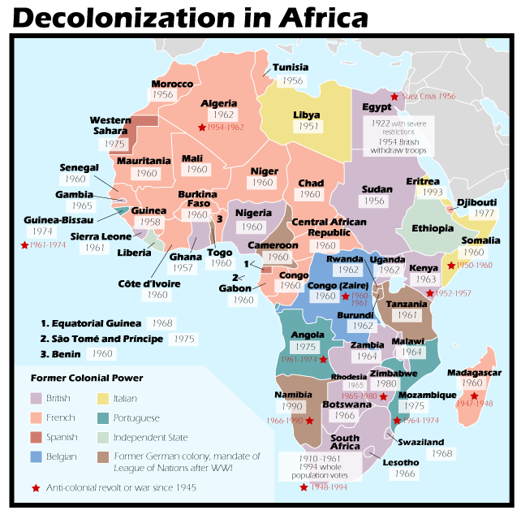
8. In what decade did most African nations become ‘independent?’

9. Which Eurpean power had the most extensive empire in Africa?

10. List the nations of Africa that saw anticolonial revolts and/or wars post-WWII.

South Africa
11. What problem did the colonies of Southern Africa face after European nations withdrew from the region and how was it (usually) resolved?

12. While the British were colonizers of South Africa, it was the Boers that considered South Africa home. Identify who the Boers were and explain their contentious relationship with the British.

13. While the National Party reflected the desires of Afrikaaners (Boers), the African National Congress’ primary mission was to bring all Africans together as one. Explain the motivations of each political party.

14. Define Apartheid and provide examples of the Apartheid system in South Africa.

15. Why did Nelson Mandela and the African National Congress abandon the policy of non-violent protest against the South African state in the 1960s? Do you think this was justified? Agree? Disagree?

17. Nelson Madela is an almost ‘mythical’ figure, not just among South Africans, but the world over. Taking in the entirety of Mandela’s life, what was it about him that endeared him to so many? What experiences, character traits and circumstances led to his ‘greatness’ and ‘mythology?’

18. The end of Apratheid might have been more violent than it was – especially reprisal attacks on the white minority of Afrikaaners – in South Africa. How does one explain this? What events or circumstances led to the mostly peaceful transition from white minority rule to Mandela’s presidency?

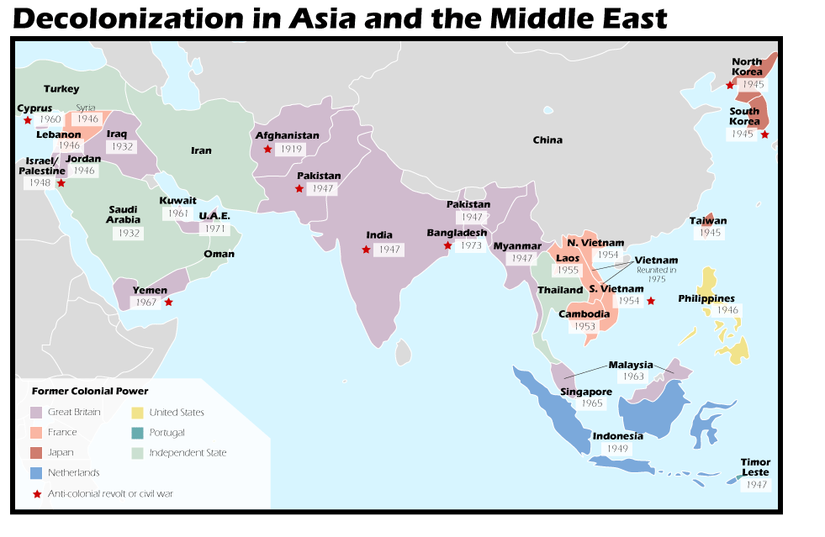

1. Which nations had become independent by the end of WWII in 1945?

2. Which nations had become independent between 1945 and 1950?

3. Which nations had anti-colonial revolts and civil wars?
4. Explain two reasons why decolonization became a reality in Asia post-WWII.

5. While Asian colonies were able to garner support from the USA and USSR for their independence, it’s important to point out that both of these ‘superpowers’ had their own interests in the region. Discuss.

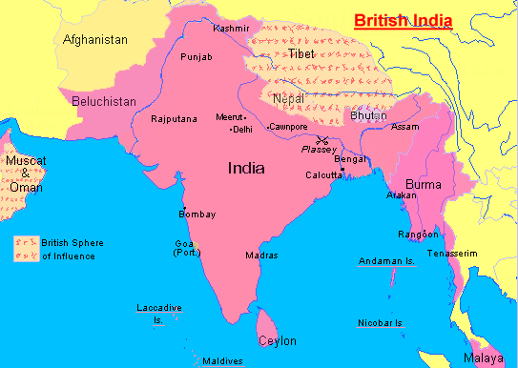
Indian Subcontinent
6. How did the British come to be involved in the Indian subcontinent?

7. How was the Amritsar Massacre a turning point for Indian leaders in their relations with the British?

8. What were the Montagu-Chelmsford Reforms of 1919? Describe the system of government created.

9. How did the Indian National Congress and Muslim League differ?

10. Describe the Government of India Act of 1935, and the election results of 1937.

11. Mohandas Gandhi influenced the likes of Nelson Mandela and Martin Luther King, Jr. most notably, by way of ideas on ‘non-violent’ movements and protest. Discuss Gandhi’s ideas and their effectiveness.

12. With the end of the Second World War, the British were quite literally, a spent force. With the rise of Indian Nationalism, they became more realistic about their presence in India, though in leaving it to Indians to decide, disagreement over the nature of Indian Independence would prevail. Explain.

13. Independence on the Indian subcontinent was achieved in 1947, though significant violence preceded and followed the so-called ‘Partition of India.’ Discuss.

14. Both India and Pakistan are among the largest parliamentary democracies in the world. They do, however, have substantial economic, social and political issues they must address. Explain.

15. Following the partition of the Indian subcontinent, which state was to become a major source of controversy between India and Pakistan? Explain.

16 What other border disputes does India have with its neighbours? Where? When? Why?

Challenge Question
In a short (4 paragraphs – intro, body paragraphs, conclusion – 500 word limit, approximately), well-considered and well-written essay, discuss the similarities and differences to decolonization in South Africa and India. What made the struggle for independence in each of these former colonies unique?

