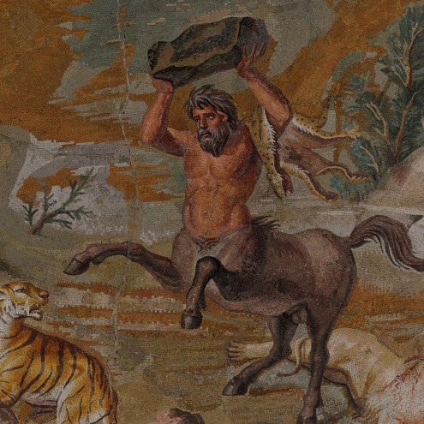
GREEK MYTHOLOGY ROLEPLAYING ASSIGNMENT
Throughout this course, we’ve discussed how a civilization’s religion reveal and
explains quite a bit about how they perceive and understand their world and
human nature. The Ancient Greeks practiced a polytheistic religion in which
each god in the pantheon was associated for particular aspects of life. Moreover,
each god’s story is didactic and is meant to teach moral lessons.

YOUR TASK
You will choose one of the gods/demigods/humans below and perform a 3 minute monologue from their perspective. You will research your character independently, but you may present in tandem with another character.

Your monologue/dialogue (if partnered) must include:
- A brief summary of your character’s myth.
- Your interpretation of what they myth explains and reveals about the Ancient Greeks and their understanding of the world and human nature.
- A prop that is relevant to your character and an explanation of its significance.
- You are to dress up in a way that is appropriate to your character. You may wear a peplos/chiton like the ancient Greeks or you can choose a modern depiction of the character.

You DO NOT need to submit a typed script of your monologue so make sure that you communicate all the required information in your monologue.

Character Options
Male Figures Male Gods Female Gods Female Figures
Achilles Apollo Aphrodite Helen of Troy
(Greek warrior in the Trojan war) (God of prophecy, archery ,music) (Goddess of love) (The defeated queen of Sparta)
Agamemnon Ares Artemis Pandora
(Greek warrior in the Trojan war) (God of War) (Goddess of the world) (The first woman on earth)

Jason Atlas Athena
(Leader of the Argonauts) (Titan asked with holding up the sky) (Goddess of wisdom and war)

Heracles Cronos Demeter
(Greatest of all heroes) (God of the sky) (Goddess of vegetation)

Perseus Dionysus The Fates
(Slayer of Monsters) (God of wine) (The goddesses of fate)

Odysseus Hades The Furies
(Lost Voyager) (God of the underworld) (The goddesses of vengeance)

Midas Hephaistos Gaia
(Wealthy King of Phrygia) (God of metal world) (Goddess of the earth)

Narcissus Hermes Hera
(Arrogant youth) (Messenger of the gods) (Goddess of marriage and childbirth)

Orpheus Poseidon Hestia
(Singer from Thrace) (God of the sea) (Goddess of the perpetual fire)

Theseus Prometheus Persephone
(Destroyer of the Minotaur) (The Titan firebringer) (Goddes of earth and queen of the underworld)

Zeus Psyche
(Ruler of the Gods) (Goddess of the soul)

