In the 'Republic of Burnaby,' Jagmeet Singh tries to prove he's more than an Instagram politician
Since he sailed to victory in the federal NDP leadership campaign a little over a year ago, nothing has seemed to come easily to Singh
BURNABY, B.C. — It’s a Thursday evening on a wide residential street in suburban Burnaby, lined with manicured lawns and cars parked on both sides of the road, and a dapper man in a yellow turban is speaking into an intercom outside somebody’s front door.
“It’s Jagmeet Singh, leader of the NDP,” he says. There’s a pause. Then: “Sorry, I’m just in the middle of something,” comes a man’s voice through the speaker. He’s uncomfortable with the television cameras waiting on his lawn, he explains.
No luck. Singh moves on, accompanied by a cluster of volunteers and a cluster of media. A little way down the road, he stops to talk with an elderly woman on her front walk. He asks what political issues concern her, and she doesn’t hesitate. The traffic on her street makes it dangerous for residents to pull out of their driveways, she says. “There’s been four accidents!” There are also some local building developments she’s not so sure about.
“Anything federal that you think is important to work on?” Singh asks. Traffic and local development, she repeats. Those are her concerns.
Singh says goodbye and carries on. He says he likes this, the challenge of breaking the ice and “getting to peek inside people’s lives,” even when that means literally peeking through doors cracked barely wide enough for him to offer a handshake.
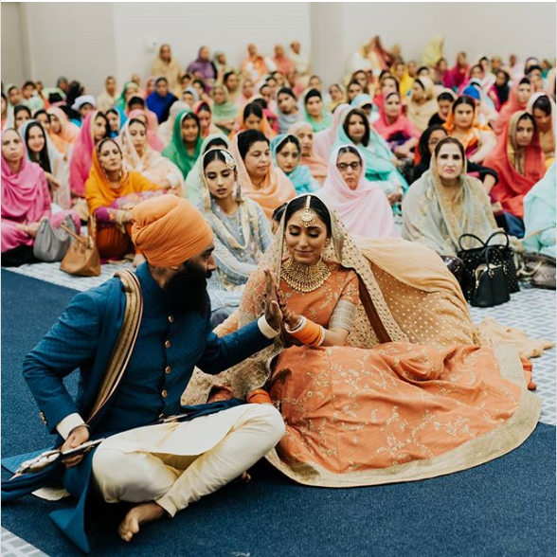

This was the muted beginning to Singh’s campaign for Burnaby South, where his political future may hang in the balance in a byelection that has yet to be called. In the end, it may not matter that it was a little lacklustre — the NDP has a strong on-the-ground machine in what locals refer to as the “Republic of Burnaby,” and if, as rumoured, the Liberals decide not to run a candidate against him, the riding may well be his to lose.
And there are certainly bright moments in this evening of door-knocking, Singh’s first campaign event in the final days before officially becoming the NDP candidate. Some cars honk at him as they go by, the drivers waving through their windows. A few passers-by sign up to volunteer on his campaign.
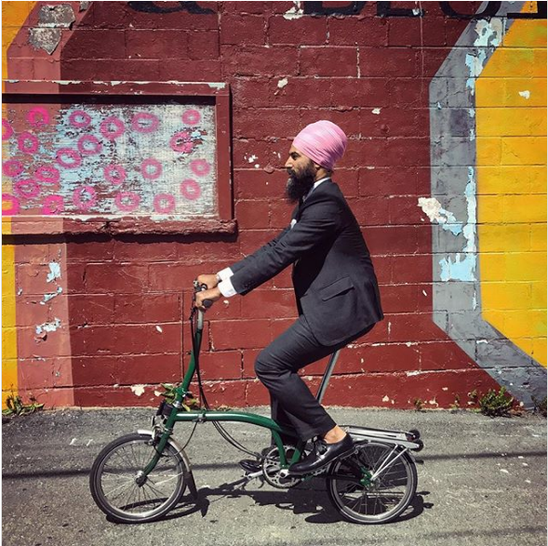
Singh has, too, a certain charm. He doesn’t hesitate to ask people for their first language — for many in Burnaby, it isn’t English — and is frequently able to rattle off a few words to them in their mother tongue, whether it’s Cantonese, Tagalog or Finnish. He claims to be able to say “How are you?” in 40 languages.
Since he sailed to victory in the federal NDP leadership campaign a little over a year ago, nothing has seemed to come easily to Singh — and if his first awkward round of glad-handing is any indication, Burnaby will be no exception. There were no crowds clamouring for selfies and handshakes, no excited murmurs as he made his way through a room. It is here, however, a city in which he has no roots and little profile, that a man made for the age of Instagram will try to prove he’s politician enough to pull his party back from the brink of electoral oblivion.
Well-dressed and social-media savvy, the 39-year-old Singh was seen as an answer to the success of Justin Trudeau — at least as photogenic and even more progressive, expected to inject glamour into a party whose history flows from prairie pulpits and union halls. But there’s a tension between Singh’s persona and the party’s base that hasn’t always remained in the background. In January, after Singh invited media to cover his proposal to his now-wife, Northern Ontario MP Charlie Angus, who finished second to Singh in the leadership race, tweeted that “When a party believes that better Instagram tricks or gala planning is the path to success we lose touch” (a tweet he later deleted).
The questions about Singh’s strength as an organizer aren’t new. For all the attention that has followed him since his entry into politics after a career as a Toronto criminal defence lawyer, there remains a sense of potential not yet fulfilled. The NDP’s high hopes for him precede last year’s leadership bid; in 2011, he came within 600 votes of winning the party’s first-ever federal seat in Brampton, Ont., and later that year defeated a Liberal incumbent in the provincial election, becoming the first NDP MPP ever to represent the Peel Region in the 905 belt outside Toronto.
The federal NDP hoped Singh’s influence would give them a regional advantage in the 2015 election, with Singh himself telling the National Post at the time he thought the party would be competitive in most Peel Region seats. It didn’t pan out. The New Democrats were shut out of the Greater Toronto Area, Singh’s coattails proving nonexistent as Trudeau’s Liberals took every seat in Brampton and Mississauga.
With the NDP polling dismally in the teens and struggling to get attention in the cut-and-thrust of Ottawa’s political bubble, Singh, who had seemed content to lead from outside the House of Commons until the 2019 general election, has faced mounting pressure from within the party to take a seat sooner rather than later. He has set his sights on Burnaby South, where New Democrat Kennedy Stewart’s Sept. 14 resignation to enter Vancouver’s mayoral contest means a byelection must be called in the next five months. Singh was nominated as the NDP candidate in the riding the day after Stewart resigned.
Burnaby South is a relatively new federal riding, formed in 2013 from parts of two former electoral districts, both NDP ridings since they were first contested in 1997 and 2004. Stewart won the new riding for the New Democrats in 2015, beating out Liberal candidate Adam Pankratz by just 547 votes.
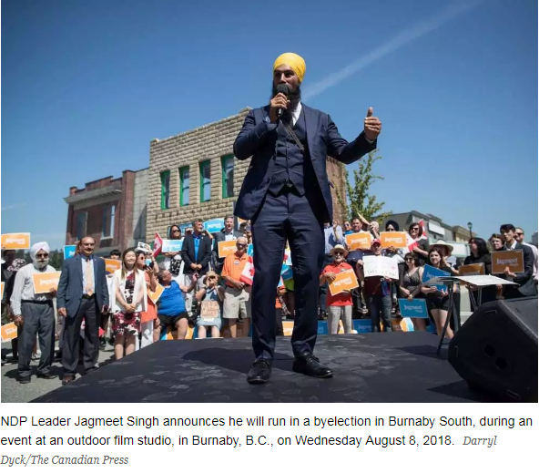

The riding is a “heartland of opposition” to the Trans Mountain pipeline expansion, according to Burnaby Mayor Derek Corrigan, though the actual pipeline terminal is not in Burnaby South. “ I … think that (Singh) has made the opposition to Kinder Morgan a centrepiece of his campaign,” Corrigan said in an interview. “So I think he feels comfortable in this community with the position he’s taken on that issue.”
Still, many Burnaby residents raise concerns about housing prices and local “demovictions” — the razing of older rental housing to make way for new condos — before they bring up Trans Mountain. “I don’t believe Trans Mountain is a deciding issue,” said Pankratz. “The proof will be in the pudding, but I don’t think that is the issue that is going to turn this riding.”
Perhaps recognizing this, Singh has not made Trans Mountain the primary focus of his campaign for Burnaby South to date, preferring instead to highlight housing. “Anytime I go to Burnaby and speak to folks, housing is top of mind,” he told the Post in an interview last month. “People are worried about how they can afford to live in the city they grew up in.”
Some observers have pointed to Burnaby’s diversity as an advantage for Singh, the first non-white federal leader of a major political party in Canada. “I think that he’ll probably feel very comfortable here, looking at our multicultural sort of community,” Corrigan said.
Support for Singh based on his ethnicity certainly exists in Burnaby. Jesse Dhillon, a local cab driver, told the Post he doesn’t know much about the federal leader, but will likely vote for him “because he’s Indian.” But Burnaby doesn’t have a large Indo-Canadian population. According to 2016 census data, more than half the population of Burnaby South are immigrants, with nearly 30 per cent of the immigrant population hailing from China. Only five per cent come from India.
Pankratz said Burnaby residents he’s spoken with are concerned that the Ontario-born-and-bred Singh, who has never lived in B.C., wants to represent a riding he doesn’t know. Singh doesn’t yet even live in Burnaby, though he says he’s looking for an apartment and plans to move as soon as possible. “I think it’s very risky and I think it’s the NDP taking Burnaby for granted that it’s a slam-dunk riding,” Pankratz said.
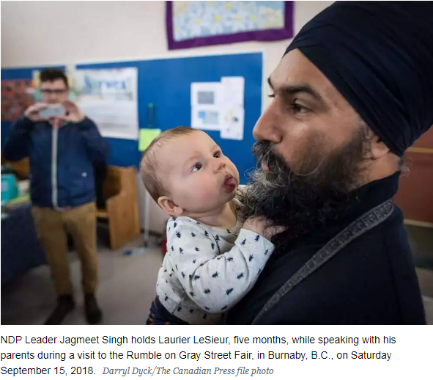
Still, Singh isn’t the first NDP leader to parachute into Burnaby. Tommy Douglas, the party’s first federal leader, was elected to the House of Commons in Burnaby in 1962 after failing to win a seat in Saskatchewan. “To see another national leader choosing to run there is something that folks are very enthusiastic about,” said B.C. MP Peter Julian.

If Jagmeet Singh still isn’t a household name in Burnaby, he does at least have the weight of a formidable NDP machine behind him. Provincially, all four Burnaby ridings are held by the NDP. All of Burnaby’s city councillors and school board trustees belong to Corrigan’s left-wing Burnaby Citizens Association.
“The whole city of Burnaby is actually referred to as the Republic of Burnaby,” said Marcel Marsolais, president of the Burnaby Edmonds B.C. NDP constituency association.
Amber Keane, Singh’s campaign manager, said the party has a large volunteer base in Burnaby that she expects will come out to help get Singh elected. She believes that through door-knocking and phone calls, they’ll be able to reach just about every person in the riding.
“I think that is a really important factor here,” said Kevin Milligan, a professor of economics at the University of British Columbia and a resident of Burnaby South. Milligan believes that Singh will have the edge in the coming campaign, but he said it’s a mistake to suggest it will be a walk in the park if the Liberals and Conservatives both run candidates against him. “Historically, there have been some really close three-way races,” he said.
However, it remains unclear what Singh’s competition will look like. The Conservatives nominated their candidate, corporate commercial lawyer Jay Shin, on Sept. 18, but the Liberals have kept their cards close to their chests. “We’re looking forward to a positive opportunity to contrast our ideas with the other parties,” said Liberal spokesperson Braeden Caley in a statement.
Pankratz, clearly hoping for a chance to unseat a federal leader, has already been knocking on doors. But he said he doesn’t yet know whether he’ll be allowed to run.
“I think it’s pretty simple,” he said. “If you think you have a chance to beat the leader of a federal party in a byelection, you do it.”
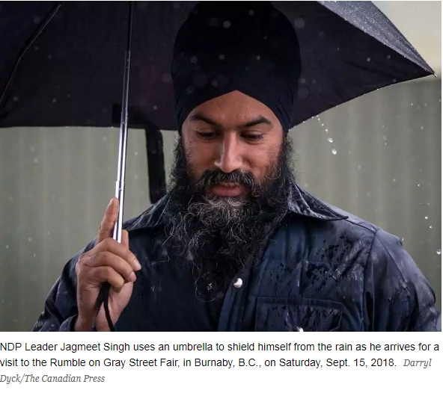
It was pouring rain as Singh arrived at a local street fair in Burnaby on a Saturday morning. He joked with the small cluster of reporters and photographers waiting for him that he didn’t want them using the weather as a metaphor for his campaign.
The sparsely attended event got off to a slow start for Singh. Some people recognized him; others didn’t. After a while, once he’d gone indoors to make his way around the local vendors’ tables, a small group of parents gathered around him to take photos of him with their children.
“The fact that he’s taking the initiative and the responsibility of being here and meeting people is really awesome for being a national leader. It’s really cool,” said Meghan LeSieur. “If he’s actively taking part and has a great platform for our area, for sure he could get my vote. Definitely.”
Others were more reticent. “I would like Jagmeet Singh to look in depth at things before he makes statements,” said Dorothy Jeffery, one of the event’s organizers, before Singh’s arrival. “He may know Toronto, but he needs to know Burnaby, he needs to know British Columbia, he needs to know the whole country, and he hasn’t demonstrated that yet.”
Jeffery follows politics avidly, and said she’s voted NDP in the past but isn’t sure she will this time. When Singh arrived, she challenged him for several minutes about his stance on tax fairness. Afterward, she seemed somewhat mollified. “He’s a personable guy, isn’t he?” she said. “He did pretty well at holding his own.”
Singh would be nominated as the NDP candidate for Burnaby South later that day, but he stayed for about an hour at the street fair, shaking hands and taking photos. At one point, he was invited up on stage to play a game with some local kids. It was sort of like musical chairs, but the winner got a cake.
The game was called a cake walk. Singh didn’t win. He didn’t acknowledge the metaphor.
EDITOR’S NOTE: This story was updated after online publication to include news that the Conservatives had nominated a candidate in Burnaby South.

