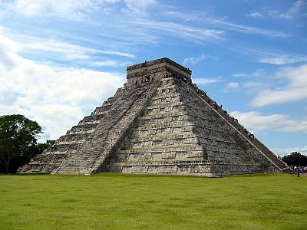
Name:
The Ancient Maya
References: DeGeer & Newman, Odyssey Through The Ages, 1992

Questions

1. Describe the various geographical areas inhabited by the Maya and how they adapted to them.

2. How do we know about the Maya? Describe the sources of information and how these combine to create a picture of Maya life.

3. How does the growth of Maya civilization challenge the concept that civilizations begin in river valleys?

4. In what ways were the Maya culturally similar? Why should they not be referred to as one people?

5. What evidence is there that Maya religion was more than just a set of beliefs and a moral guide and that religion, in fact, pervaded every aspect of their life?

6. Discuss the Maya method of reckoning time and what role it played in Maya life.

7. Create a visual depiction of the class system of Maya society. Be sure to include all levels.

8. Compare and contrast the role played by women and men in everyday Maya society.

9. What do we know about Maya sport and entertainment?

10. Describe the nature of Maya food. What were the main ingredients? How was the type and preparation of the food indicative of the level of society in which it was consumed?

11. Despite the fact that Maya architecture does not reflect the jungle environment, it is an accurate depiction of the society that produced it. Discuss this statement.

12. Which elements of Maya culture demonstrate that they were an advanced and highly literate society?

13. How did trade contribute to the standard of living in Maya cities? Of what importance to Maya life was the extensive trade network which existed. With whom did the Maya trade?

14. How would you compare Maya civilization to other civilizations we have studies? More advanced? Less advanced? In answering this question, review key elements of civilization (class, government, religion, food supply, technology, etc).

