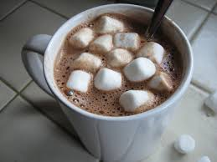
Campbell’s English – Short Story Questions
Hot Chocolate – by Heath Johns

Please answer on a separate sheet of paper.

1. At the beginning of the story, how does the narrator characterize his relationship with his mother? Explain how they get along, and include some direct quotes from the story to support what you’re saying and to demonstrate the nature of their relationship.

2. Why does the mother want the protagonist to have some hot chocolate? Why does he not want to drink it? At this point in the story, what could the hot chocolate symbolize*?

3. What is the main conflict of the story? What is the climax of the story? Explain why you think so.

4. What does the mug that says, “My mom’s from Sweden, why’d you ask?” symbolize at first? What could it symbolize after the climax?

5. How is the ending of the story IRONIC? Explain which kind of irony it is, and WHY it is ironic. (See irony slides on back of sheet).

6. What does the narrator mean by the last line, “For the first time in years, I was more than her son, and she was more than my mother.” What significance does this have for their future relationship – i.e. how do you expect them to get along from now on?

7. Other than “connection”, what are some of the theme topics from the story? Write one THEME STATEMENT for “connection”, as well as one other theme. (See Short Story Terms Handout p.7-8).

* Symbol – an object, person, event, or place that represents an IDEA or qualities. Symbols usually have special meaning in particular situations and contexts. For instance, a red rose growing in a garden is just a flower; a boy giving his girlfriend a red rose symbolizes love.
*Symbolism – the use of symbols to represent ideas or qualities
* Symbolize – to represent by means of symbols

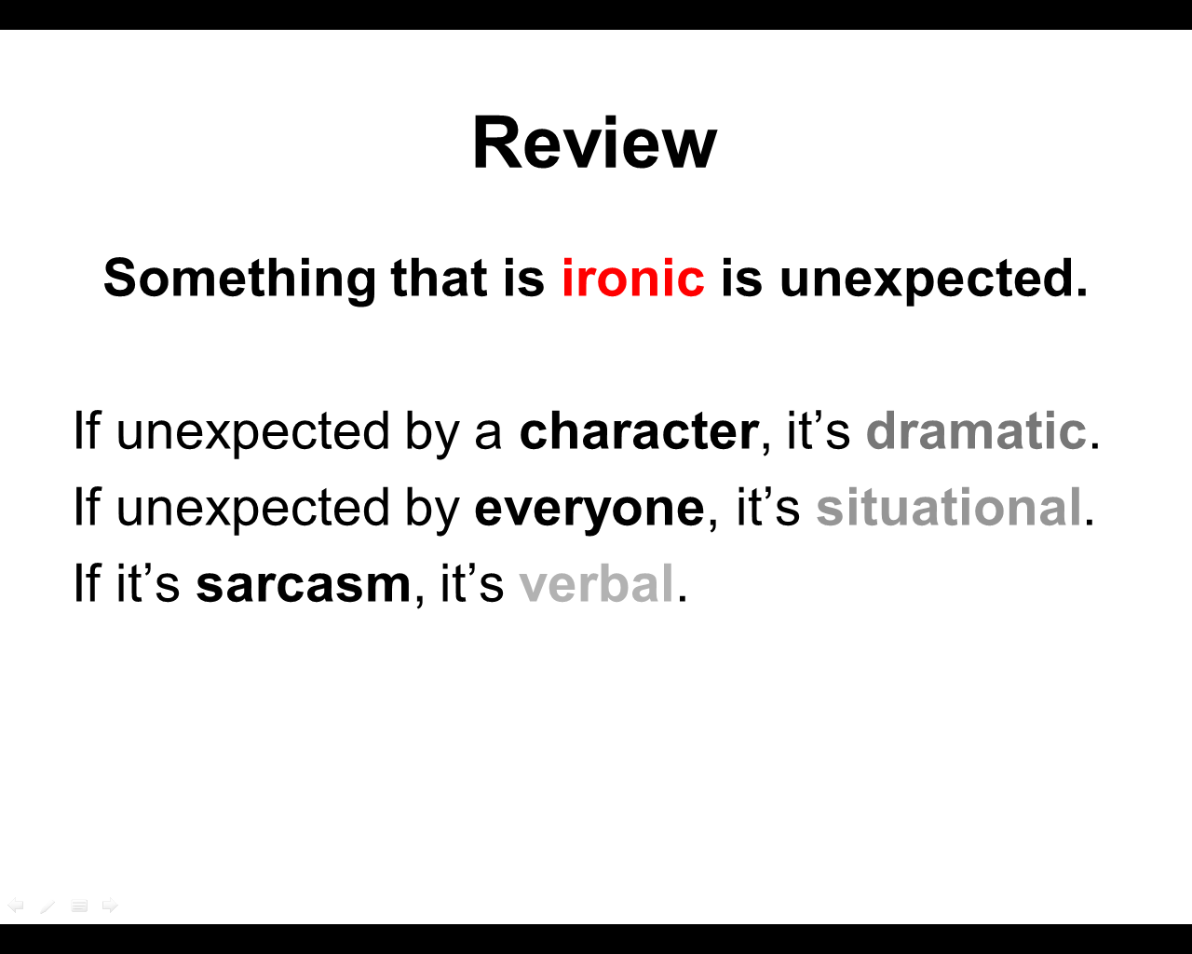
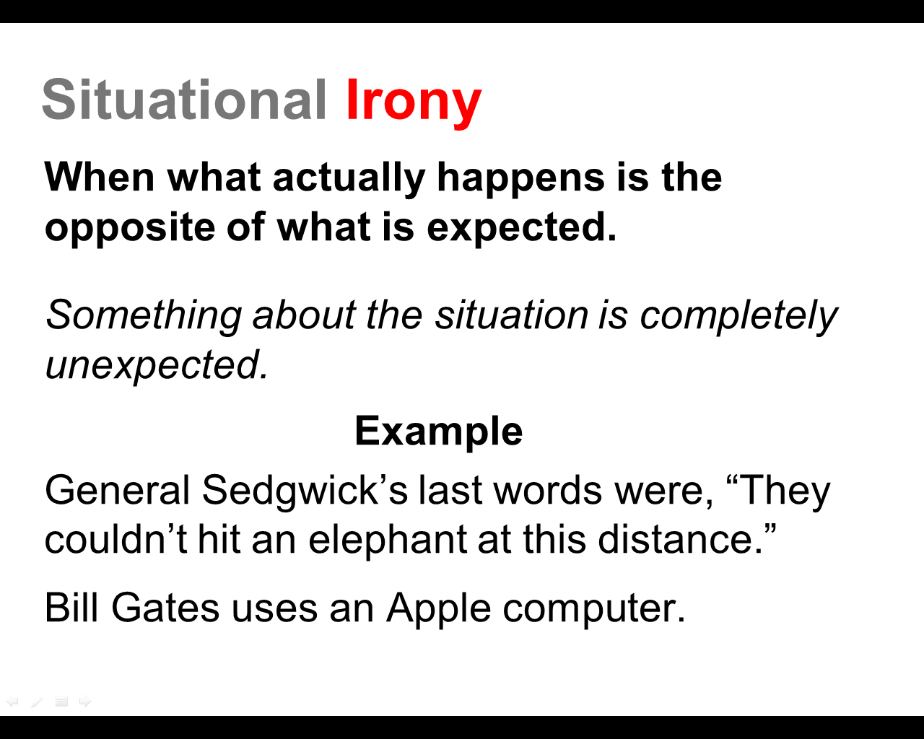
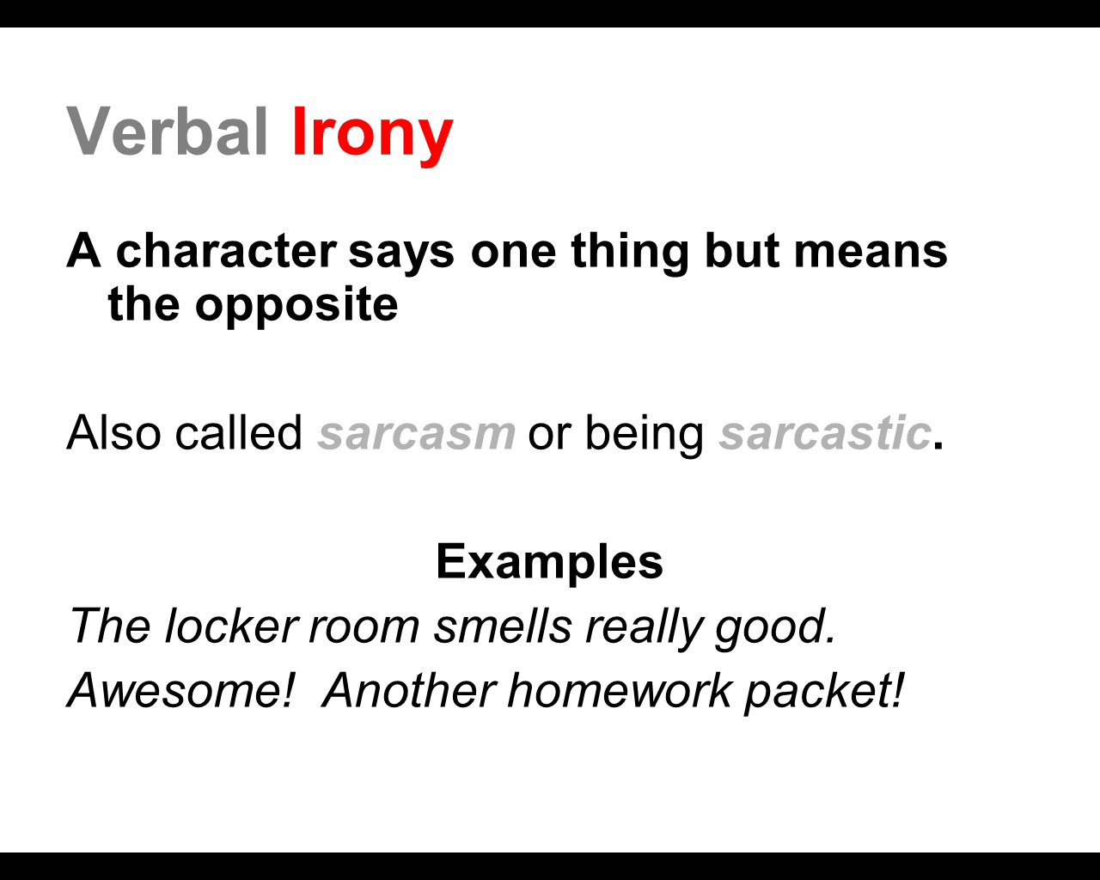
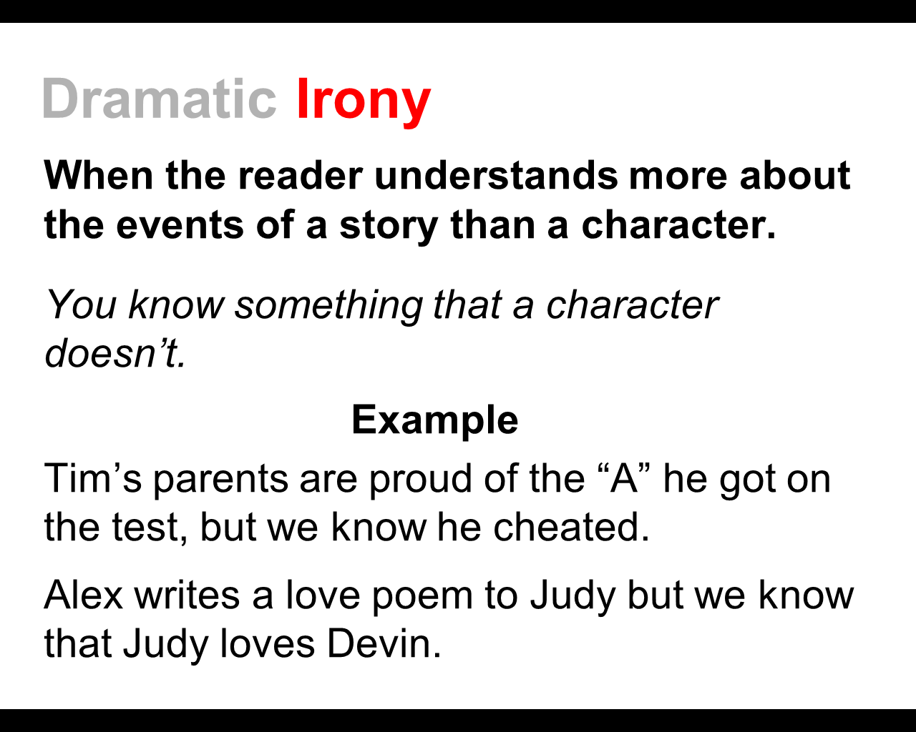
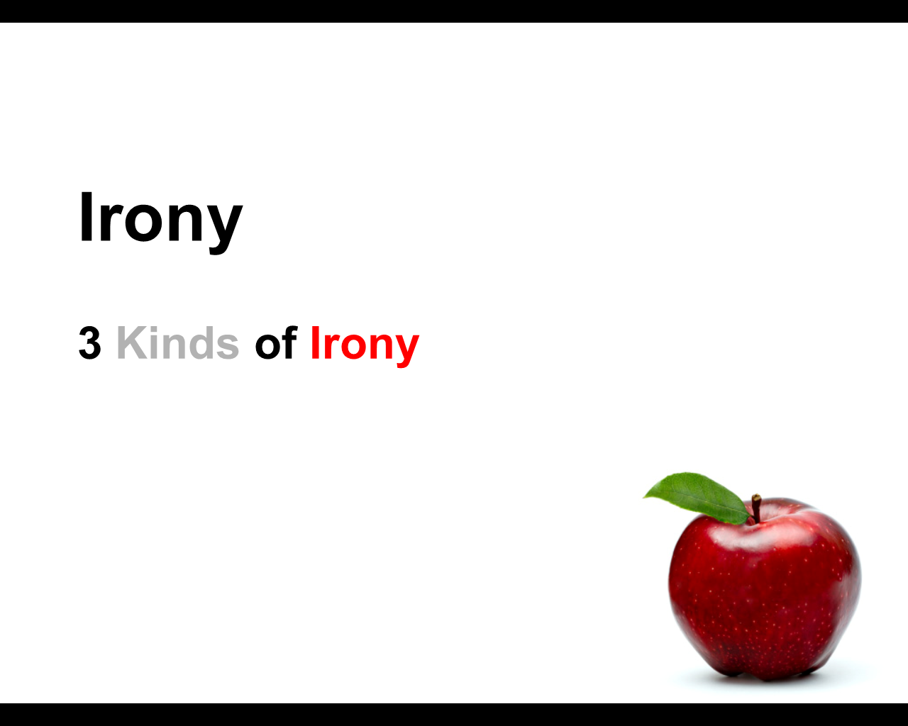
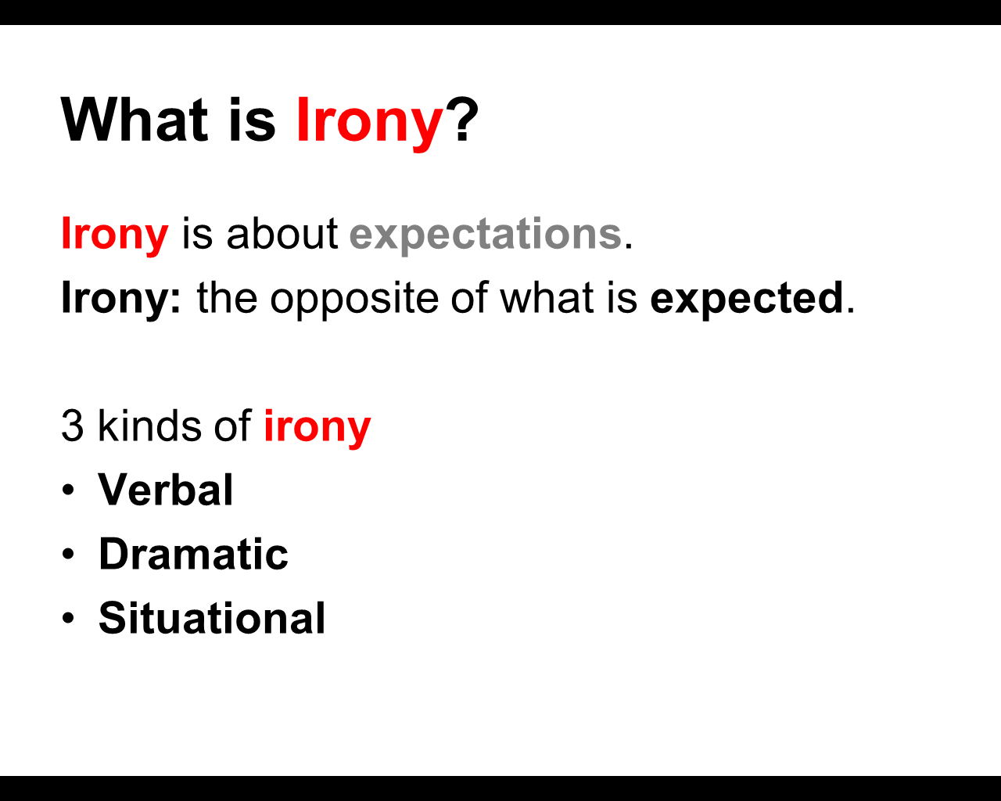

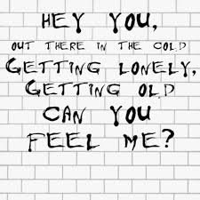
Hey You
by Pink Floyd (Waters)
Hey you, out there in the cold
Getting lonely, getting old
Can you feel me?
Hey you, standing in the aisles
With itchy feet and fading smiles
Can you feel me?
Hey you, don’t help them to bury the light
Don't give in without a fight.
Hey you, out there on your own
Sitting naked by the phone
Would you touch me?
Hey you, with you ear against the wall
Waiting for someone to call out
Would you touch me?
Hey you, would you help me to carry the stone?
Open your heart, I'm coming home.
But it was only fantasy.
The wall was too high,
As you can see.
No matter how he tried,
He could not break free.
And the worms ate into his brain.
Hey you, standing in the road
always doing what you're told,
Can you help me?
Hey you, out there beyond the wall,
Breaking bottles in the hall,
Can you help me?
Hey you, don't tell me there's no hope at all
Together we stand, divided we fall.

Tamara's Opus*

by Joshua Bennett

http://www.youtube.com/watch?v=MVvzw7d11Q8

* An opus is any artistic work, especially one on a large scale.

Tamara has never listened
to hip-hop
Never danced
to the rhythm of raindrops
or fallen asleep to a chorus of chirping crickets
she has been Deaf
for as long as I have been alive
and ever since the day that I turned five
My father has said:
"Joshua. Nothing is wrong with Tamara.
God just makes
some people different."
And at that moment
those nine letters felt like hammers
swung gracefully by unholy hands
to shatter my stained-glass innocence
into shards that could never be pieced back together
or do anything more
than sever the ties between my sister and I.
I waited
was patient numberless years
anticipating the second
her ears would open like lotuses
and allow my sunlight sentences to seep
into her insides
make her remember all those conversations
we must have had in Heaven
back when God hand-picked us
to be sibling souls centuries ago

I still remember her 20th birthday
readily recall my awestruck eleven-year old eyes
as I watched Deaf men and women of all ages
dance in unison to the vibrations
of speakers booming so loud
that I imagined angels chastising us
for disturbing their worship
with such beautiful blasphemy
until you have seen
a Deaf girl dance
you know nothing of passion.
There was a barricade between us
that I never took the time to destroy
never for even a moment
thought to pick up a book and look up
the signs for sister
for family
for goodbye, I will see you again some day
remember the face of your little brother.
It is only now I see
that I was never willing
to put in the extra effort to love her properly
So as the only person in my family
who is not fluent in sign language
I have decided to take this time
to apologize
Tamara, I am sorry
for my silence.
But true love knows no frequency
So I will use these hands
to speak volumes
that could never be contained
within the boundaries of sound waves
I will shout at the top of my fingertips
until digits dance and relay these messages
directly to your soul
I know
that there is no poem
that can make up for all the time that we have lost
but please, if you can
just listen
as I play you a symphony
on the strings of my heart
made for no other ears on this Earth
but yours.

‘Connection’ Theme Questions

“Hot Chocolate” by Heath Jones
“Tamara’s Opus” by Joshua Bennett

Please answer on a separate sheet of paper.

1. What are the similarities and differences between the two pieces in terms of: (see chart to help you take notes)
- plot (circumstances / what happens),
- main characters,
- setting (including mood),
- conflict,
- point of view, and
- tone (the feeling with which the author of story, song or poem treats his subject – the attitude towards the subject).For the song and poem, discuss how the use of music and the way the spoken word poem is delivered affect the tone.

2. How does the theme topic of connection relate to the two pieces (short story, song, or poem)? Write a THEME STATEMENT for each piece that demonstrates how the theme of connection is handled. Is the THEME STATEMENT for all three pieces the same or different? Explain.

3. Explain how each piece helps DEMONSTRATE the theme through things like:
- what characters or the narrator (person or voice “telling” the story/song/poem) DOES or SAYS
- what happens
- specific lines / quotes
- word choices )(especially in poem and song)
- figurative language (usually in the form of comparisons such as metaphors, similes, personification, etc.)
- symbols
- irony

4. What other themes / theme topics do you notice in the different pieces? What are the similarities and differences between them? Be prepared to explain.
Similarities and Differences
Element | Similarities | Differences
Plot

Characters

Setting

Conflict

Point of View

Tone

Theme

