MUSIC VIDEO ASSIGNMENT

You may work in pairs for this assignment. Each person is responsible for contributing to the assignment and doing their fair share of the presentation to the class. All elements should be presented (BOTH in writing or orally) clearly and thoroughly.

Your Mission, should you choose to accept it…(OK, you have no choice…):

Part 1 – Choose a music video that tells a story and provide the following information: (/5)

- The band / artist name
- song writer(s)
- music video director
- the URL of where to watch the video online
- lyrics of the song

Part 2 – Analysis and Short Story Terms – Video (/20)
- Give a 3-5 sentence plot synopsis of the story in the video. (/5)
- Identify the protagonist, antagonist, and therefore, the type of conflict and explain. (/3)
- Identify the climax and the type of ending and explain. (/2)
- Identify the following Plot and Literary Devices: setting (including MOOD), at least 2 symbols, and any foreshadowing, irony, suspense, or other plot or literary devices such as dilemma and flashback, that are used in the video. Explain how these help reinforce the theme of the song or the story, or add to the effectiveness of the story. You must identify and explain at least THREE examples of these elements in addition to setting and symbols. If your video doesn’t have four examples, then choose another video! (/10)
Part 3 – Analysis of Theme and Lyrics (/15)
In paragraph form:
- Interpret and Analyze the video’s message and offer one or more theme statements that demonstrate what you believe to be the main underlying message(s) of the video. Explain the reasoning for your theme statement(s) in a few sentences.
- Based on these theme statements, explain how the director’s choices regarding elements such as setting/decor, camera angles, cinematography, colour schemes, lighting, costumes, additional sounds (other than the music – i.e. does it have dialogue as well?), editing, genre/style contribute to the themes of the song and video. Please include examples from the story, lyrics, and images in the video to support your reasoning.
- Compare your theme statement and analysis of the video with an analysis of the song’s lyrics. Do you think that the theme of the video is the same or different than the main theme of the song? EXPLAIN using evidence from BOTH the video and lyrics.
You can do the Interpretation and Comparison SEPARATELY in different paragraphs or TOGETHER in 2-4 paragraphs, as long as all elements are addressed.
Part 4 – Poetic Devices in Lyrics (/10)
- Analyze the song lyrics and choose at least five examples of poetic devices. These can include (but are not limited to) similes, metaphors, personification, hyperbole, oxymoron, paradox, alliteration, or assonance. Only one of the four devices may be alliteration, however. Repetition and rhyme DO NOT count.
Part 5 – Presentation (/15) – Tuesday, May 23rd and Wednesday, May 24th
Both (or all) members of the group are responsible for presenting the above information to the rest of the class. Presentations should follow this general order:
- Introduce the Video, along with the Band/ artist and Song Title, and play it for the class.
- Explain Parts 2, 3 and Part 4 of your written assignment to the class in a concise, clear, interesting, and engaging way. You do not need to go in the order of the assignment if mixing things up works better for you. Extra marks for creative presentations!
- Accept questions from the audience and/or your teachers and be prepared to answer them. This will demonstrate that you have thought through your information and can provide reasoned responses to why you chose the theme, symbols, etc. that you did.

This assignment is due on the day you present –
either Tuesday, May 23rd or Wednesday, May 24th
It is worth 65 Marks.
Assessment Overview:
Use the assignment criteria like a checklist – if you do everything on the list thoroughly, you will be “Fully Meeting Expectations” (C+-B range).
If you do everything on the list, but not to a high level, you will be “Meeting Expectations” (C-C+ range).
If you go over and beyond what was asked of you, you will be “Exceeding Expectations” (B+-A range).
If you miss things on the list, or do not cover them thoroughly, you will be “Not Meeting Expectations” (C- or lower).

EXAMPLE:
Part 1
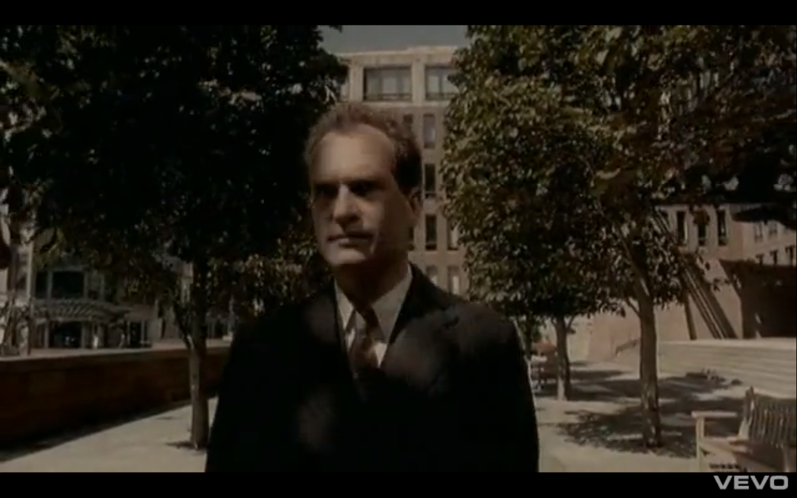
Video: Radiohead – “Just”
URL: http://www.youtube.com/watch?v=-_qMagfZtv8
Album – The Bends released in 1995
Director: Jamie Thraves.

LYRICS for ‘Just’
by Thom Yorke

Can't get the stink off
He's been hanging round for days
Comes like a comet
Suckered you but not your friends
One day he'll get to you
And teach you how to be a holy cow
You do it to yourself, you do
And that's what really hurts
Is that you do it to yourself
Just you and no one else
You do it to yourself
You do it to yourself
Don't get my sympathy
Hanging out the 15th floor
You've changed the locks three times
He still comes reeling through the door
One day I'll get to you
And teach you how to get to purest hell
You do it to yourself, you do
And that's what really hurts
Is that you do it to yourself
Just you, you and no one else
You do it to yourself
You do it to yourself
You do it to yourself, you do
And that's what really hurts
Is that you do it to yourself
Just you, you and no one else
You do it to yourself
You do it to yourself.. yourself.. yourself..

Part 2
1. Plot Synopsis:
A clearly unhappy man has a bath then decides to go downtown and lay down in the middle of the sidewalk. One man in particular trips over him and beings to question him about why he is doing what he is doing. He refuses to tell or to move. More and more people gather and are perplexed by the situation. A police officer shows up and eventually demands to know why the man is laying down on the pavement. A crowd gathers and after some significant pestering, the man reluctantly tells the crowd why he is lying there. The video ends with everyone lying down on the pavement.

- Characters & Conflict

The protagonist is the man in the suit who lies down on the pavement. At first the conflict seems to be internal (Man vs. Self), as there does not seem to be a logical reason for him to do this, and he seems to be depressed. Then when the man trips over him, the conflict shifts to Man vs. Man, with he and other people who gather around him demanding that the protagonist tell them why he is doing this. When everyone lies on the pavement after being told the mystery reason, it seems the overall conflict really is Man vs. Society, but it is not entirely clear whether it is a comment on everyone getting caught up in the hype of a seemingly meaningless incident or idea, or whether the man is leading a revolution of some sort. So the antagonist shifts from internal to the other people, to society. The ending, however, seems to support the overall main conflict of Man vs Society.
3. Climax & Ending
The climax is when the protagonist tells everyone the mystery reason he is lying on the pavement. The type of ending is surprise because it is unexpected that people would join him in lying down, especially when we the audience do not know the reason.
4. Plot and Literary Devices
1) Setting: The video is set in a large, nondescript city, in what appears to be the present day. The mood is dark and depressing.
2) Suspense: We are intrigued as to why the man is lying on the road, and his reluctance to tell the man who tripped on him why leads us to want to know even more.
3) Symbol: the suit the protagonist wears symbolizes conformity in society.
4) Symbol: the police officer symbolizes authority.
5) Symbol: the people who lie down symbolize the conformity in society.
6) Irony: The ending creates situational irony in that we do not expect, nor does it seem logical, for everyone to lie in the road after being told why the man is doing so.
Part 3 – Analysis of Theme
Theme Statements:
- People tend to bring negative circumstances on themselves.
- People can be too easily swayed by what is popular instead of following their own instincts.
- The answers to life’s questions can cause more questions.

Interpretation and Comparison:
“Just” seems to be about how people bring negative things onto themselves, as the lyrics, “you do it to yourself, you do” implies. The protagonist in the video seems to experience a negative revelation of some sort that causes him to lie on the ground. We, the viewer, are never sure of what this is: is it guilt? is it that he should just give up? Is he being rebellious and breaking free of society’s norms? This is up to interpretation. It also seems to be a comment on how the majority in society give in to and accept or support what is popular without giving it enough serious consideration and thought. This is supported by the lyrics of the first stanza: “Can't get the stink off / He's been hanging round for days / Comes like a comet/ Suckered you but not your friends / One day he'll get to you /And teach you how to be a holy cow.” To be “suckered” is to be sucked into believing something that is not true or real, and to teach someone to be a “holy cow” implies teaching someone to be revered or loved and put on a pedestal, both of which are part of hype or gaining popularity. The mindlessness that this involves is a problem in society – people blindly following trends and hype instead of forming opinions for themselves. This can lead to a less fulfilling life, and therefore, the depression that the protagonist in the video exhibits.
The video also demonstrates that when we ask questions in life, we are not always going to like the answers, and so we have two choices – to give in to the negative feelings, or fight them. The video and song both imply that people too often give in to negative feelings and let their lives be ruled by negativity – whether from the media (hype) or society in general, or from other people, or within themselves. This is supported by the lyrics: “Don't get my sympathy/ Hanging out the 15th floor / You've changed the locks three times / He still comes reeling through the door / One day I'll get to you / And teach you how to get to purest hell.” The “hanging out on the 15th floor” could indicate thoughts of suicide or simply an overly conventional life of working in an office building. The changing of locks implies paranoia or trying to keep negative things out, but they get in despite our efforts. The line “I’ll get to you and teach you how to get to purest hell” implies that our dark side is always ready and waiting to bring us down.
Interestingly, because we do not know what the protagonist says at the end of the video, it is unclear whether the people lying down with him are rebelling or conforming. It is up to the viewer to decide. The ambiguity lends itself to a more compelling story and more possible interpretations of the video and song’s message.
The director’s choices also reinforce the themes of conformity and confusion. The colour palette and lighting are muted, reinforcing the feeling that everything is the same or ordinary. The fact that one cannot identify the city makes it “universal” and a blank slate onto which the song projects. The ordinariness of the actors and costumes also add to this. They are all wearing business suits and seem to be blindly going to work. The contrast between the dynamic shots of the band, who are looking down on the scene with the man in the street below them, almost god-like, and the people on the street who seem reserved and controlled is another choice that reinforces the tension in the video. The choice to have dialogue in the form of subtitles also adds to the story, as we want to know why the man is lying down – is he giving up? Making some sort of protest? Is he “doing it to himself”? It is unclear and therefore intriguing.

Part 4 – Poetic Devices in Lyrics
- “can't get the stink off” – “the stink off” – metaphor for something that won’t go away
- “comes like a comet” – simile & alliteration (c’s)
- “how to be a holy cow” – comparison to something revered in society & alliteration (h’s)
- “purest hell” - oxymoron

