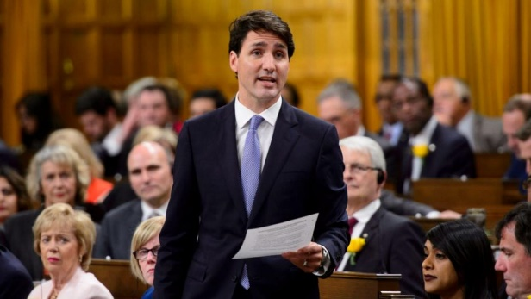
Name:
Social Studies 10 – Politics and Government
The Operation of Government

Reference:
Counterpoints, p. 304-313
Video: Government in Canada (see handout)

Questions:
1. How is our parliamentary system set up? (p. 304)

2. What are some functions of government? (p. 305)

Define the following:

civil service

bureaucracy

PMO

PCO

Cabinet solidarity

Order-in-Council

3. Explain the role of the Cabinet in governmental affairs. What are the responsibilities of Cabinet ministers? (p. 306)

4. What are the steps in the passage of legislation? (p. 308)

5. How do political parties ensure support among their members?

6. When might free votes occur in the House of Commons?

7. Why are private members’ bills seldom passed?

8. What are some advantages and disadvantages to minority governments? (p. 310) Make a +/- chart.

Define the following:

coalition

prorogue

dissolution

9. What are the differences between the provincial and federal legislatures? (see chart)

Federal Government | Provincial Government
Governor General

Senate

House of Commons

Prime Minister

Cabinet

Member of Parliament (MP)

10. What are some specific areas of interest to provincial governments? (lecture/powerpoint)

11. Do you think that citizens should have more say in deciding government policy? Consider the pros and cons and explain your answer. (p. 312)

Can you figure these out?:

1. Who is the current Governor General? ___________________________________________________
2. What is the name given to the part of the constitution setting out how changes can be made? _____________________________________________________
3. How many provinces have to agree to change the constitution? _______________________________________
4. Name the country from which our unwritten constitution originated. ________________________________
5. What is the name of the powers not mentioned in the constitution? __________________________________
6. Name the body that makes decisions regarding federal-provincial disputes. _________________________________________________________
7. What is another name for the House of Commons? ___________________________________________
8. What is the maximum amount of years between elections? _____________________
9. Who can decide to call an election before the maximum number of years? ___________________________
10. Who elects the Speaker of the House? __________________________________
11. What is a meeting made up of elected members of a party called? __________________________________
12. Who calls the actual elections? ________________________________________
13. What is the term for cabinet members agreeing publicly with cabinet decisions (not disagreeing in public)? _____________________________________________________________________
14. What is the name of the permanent employees who perform the ongoing business of government? ________________________________________________
15. Who chooses Cabinet? _______________________________________________
16. What name is given to the person who ensures that all members are present to support party bills and vote in the House of Commons? ____________________________________________
17. Where do most bills originate? ___________________________________________________
18. How many readings in the House of Commons? ___________________________________________
19. What do they call the Legislature in British Columbia? ________________________________________________
20. What is another name for an ‘alderman’? ______________________________________________
21. What is the aboriginal equivalent of a municipal council? __________________________________________
22. Which government is responsible for education? ___________________________________________________
23. Which government is responsible for garbage collection? __________________________________________
24. Which government is responsible for allocating driver’s licenses? __________________________________
25. Who is the Lieutenant Governor of British Columbia? _________________________________________________

