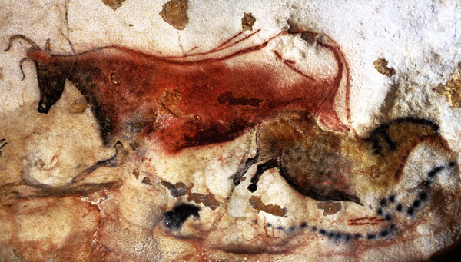
Comparative Cultures 11
Prehistoric Art
Focus Questions:
How do people express ideas through art?
Why do people use images to tell stories and to communicate?
What did people use to record important events in their lives long ago?
How has art been used to tell stories or to show us what people in other times and places considered important?

Lascaux Cave Paintings
Reference: http://archeologie.culture.fr/lascaux/fr

Instructions: Go to top left of webpage and ‘click’ on Menu...work through the website in chronological order here.

‘Visit (of) the Cave’
Take the virtual tour of the cave.
Questions
1. What do you see? Specifically, what animals do you see? And, what don’t you see, as well?

2. What can the paintings tell us about other aspects of the life of cave dwellers or Paleolithic people?

Parietal Art
3. List the challenges the people who created this art might have encountered in painting (and engraving) on cave walls and ceilings.

4. Explain how the people who created this art overcame the challenges listed above.

5. As a result of excavations at the site, what did archaeologist discover in and about the caves?
See also: ‘Archeological Research’

6. What colours are prominent in the paintings, and what natural sources might provide these pigments?

Archeological Research
7. What have scholars made of the paintings so far as ‘interpreting’ the images sprinkled throughout the caves?

Extension Activity
For a broader understanding of cave paintings and Paleolithic humans, explore the following cave (web)sites.

The Cosquer Cave
http://web.archive.org/web/20070205221029/http://www.culture.gouv.fr/culture/archeosm/en/fr-cosqu2.htm

This website describes the Cosquer Cave located at Cape Morgiou, near Marseilles on the Mediterranean Sea. The unique feature of this cave is that it contains several dozen works painted and engraved between 27,000 and 19,000 years ago. It is decorated with a variety of land animals, but also with seals and auks, fifty-five hand stencils, and numerous digital markings, dozens of geometric symbols, as well as the extraordinary representation of a "slain man." Like the Cave at Lascaux, the Cosquer Cave is closed to the general public in order to keep it protected, but a virtual tour of the cave is available at the above website.
For a general overview, you can check out the following features:
- Map of coastline of France
- Overview of Cosquer Cave
- Diagram of cave with red dots that contain hyperlinked images to the cave's contents
- Prehistoric handprints

Note: Some handprints have shortened or missing fingers……what is the significance of this?
The Cave of Chauvet-Pont-d'Arc
http://web.archive.org/web/20060220095458/http://www.culture.gouv.fr/culture/arcnat/chauvet/en/index.html
This cave website has general background information on the evidence for Aurignacian peoples found in Germany, Austria, France, Spain, and Slovakia. Click on "Time and Space," "Archaeological Context," and, for climate and environmental conditions, click on "Geographic Context." According to the information found on the website, this archaeological site is a particularly important find for the Upper Paleolithic period because the cave was found in the Ardèche region of France, not the area generally associated with a proliferation of cave art sites. Not only are there animals here rarely depicted in cave art (for example, lions) but also the dynamic and sophisticated quality of their representation is extraordinary.

