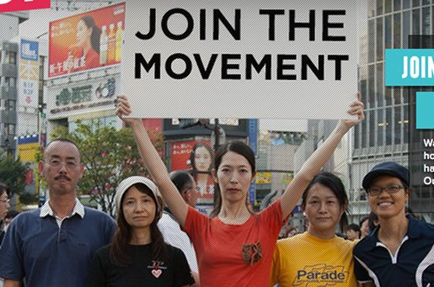
Poli Sci 12
Social (Protest) Movements Assignment

Topics: | Persons:
- March of Our Lives | - Maddie/Brooke
- Black Lives Matter | - Chiara/Sarah
- Idle No More | - Gus/Ben/Haley
- Arab Spring | - Rosemary/Ece

Presentation Dates:

Mon, November 26th – March of Our Lives
Tues, November 27th – Arab Spring
Wed, November 28th – Black Lives Matter
Thurs, November 29th – Idle No More

Content:
You will present a lesson to your peers on the topic assigned.

Intro/Origins:
- catalyst? ….the spark the lit the fuse, that blew the powder keg open….
- factors? ….the key factors that led to this protest movement…
- seeking change? ….what were/are the actors in this movement seeking?

Characteristics:
- violence? …..to what extent is violence a part of the movement? non-violence?
- tools? …what ‘tools’ have sustained movement? (social media? civil disobedience?)
- impact? …has this been an effective movement? pan-national, global? timeline?
- problems? …what barriers/limitations does this movement face?

Assessment:
- significance? ...has this movement affected change in institutions of power?
- influence? …what makes a movement? what is your advice for future activists?

Criteria:
Your presentation run approximately 40 minutes and include:

- Hook
  - an engaging beginning…..newsworthy? provocative? evocative?
- Slideshow
  - imagery
  - point form notes….brevity; avoid text overload (power point making 101)
- Reading
  - You must distribute a reading to the class for discussion.
  - Reading should take 5-10 minutes and provoke some discussion
  - You must pose questions to your peers to illicit response and discussion

