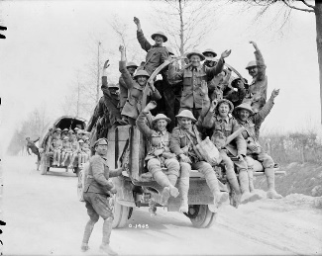
English 11
Response #3 – Vimy Ridge – Birthplace of a Nation – or of a Canadian myth?
The battle, which marks its 100th anniversary this year, has long been touted as the defining event that unified Canada. Whether or not it did, its symbolism endures.

Peter Mansbridge: Why Vimy Matters From The National (CBC)
http://www.cbc.ca/news/canada/why-vimy-matters-peter-mansbridge-on-a-battle-that-defined-us-1.4056108
See also: Robert Everett Green’s ‘Vimy Ridge: Birthplace of a Nation – or of a Canadian myth?’ From The Globe and Mail (April 5, 2017)
Weblink: http://www.theglobeandmail.com/news/national/battle-of-vimy-ridge-first-world-war/article34515113/

Questions to consider:
- Why was Vimy Ridge significant to the development of Canada’s national identity?

- What is the counter-narrative to the argument Vimy was a defining moment and the birth of the Canadian nation? Is Vimy really a universally accepted symbol across Canada and for Canadians?

- A century later, what should the Battle of Vimy Ridge mean for Canada and Canadians?

