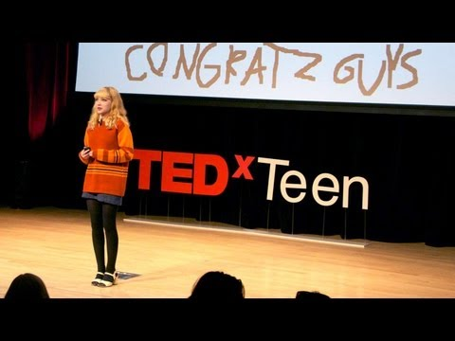
English 11

Response #8 - Tavi Gevinson: A teen just trying to figure it out

http://www.ted.com/talks/tavi_gevinson_a_teen_just_trying_to_figure_it_out.html

Questions to consider:
1. As a teen, do you relate to Tavi’s feelings of “just trying to figure it out”, and not always feeling confident with that process? Discuss your own feelings and experiences surrounding this.
2. If you are a girl: Do you agree that there are not enough strong women role models for you in the media, or that they are only one dimensional? Explain. Why do you think that is?
3. What does the word “feminist” mean to you and why? Do you think of it as a positive or negative word? Why? If you are familiar with the history of feminism, where do you think women are now in that process?
4. If you are a boy: You may feel that what Tavi is talking about doesn’t apply to you, but you could not be more wrong. Women are part of your life –as mothers, grandmothers, aunts, (teachers!), sisters, friends, and maybe even girlfriends. Do you feel the media helps you understand the women in your life better, or do you agree that the way they are often portrayed does them an injustice? Would you like the media to portray them more realistically so you have a more realistic picture of how to understand them and relate to them? Why or why not?
5. What are some of the potential impacts /effects on both men and women of portraying women as stereotypes (one dimensional / flat) characters who do not have depth or complexities (flaws)?
6. If you could create a realistic female character, tell me about what she would look like, sound like, act like, what would be the context for her life and the situations she would be in etc…

