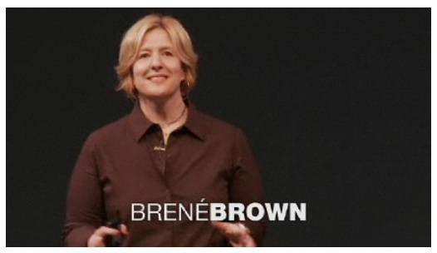
English 11 - Response # 9
TED Talk – Brene Brown
The Power of Vulnerability
http://www.ted.com/talks/brene_brown_on_vulnerability.html

Task #1:
Taking notes while listening is an important and useful skill. You will be practicing this skill while listening to Brene Brown’s talk. You should be focusing on important information, not writing down every little thing. Use point form and abbreviations to help you write faster.

To help with this, you should pay particular attention to these cues:

- Connection vs disconnection
- Shame
- Vulnerability (comes up several times)
- Feelings of worthiness vs. feelings of unworthiness
  - (& the one variable that separates the two!)
- What people who are “whole-hearted” have in common (4 things!)
- What people tend to do to deal with vulnerability (you note DETAILS) – 5 main things
  - Numb it (make note of all the different ways…)
    - How and why we numb
  - Want to make things that are uncertain, certain
  - Blame
  - Goal of perfection
  - Pretending
- What she suggests we do INSTEAD of the above methods to deal with vulnerability

Task #2:
Using the notes you took, answer the following questions linking the video to your own life:

1. Brown says that connection is “why we’re here”, and gives people purpose and meaning to their lives. Do you agree or disagree? Can you think of examples from your own life that support your opinion?
2. Brown explains that the fear of disconnection causes people to feel shame. Can you think of times, past or present, that you do not feel “worthy”, or “good enough”? Explain the circumstance and why you feel this way at those times (or all the time!). Now try to take a step back and look at it objectively. Do you think someone looking at you would guess this is how you feel? What could you do from now on to try to look at this situation differently and feel less shame?
3. Hearing that people who have a sense of worthiness have it simply because they BELIEVE they are worthy of love and belonging is a powerful concept. Based on the characteristics of “whole-hearted people”, what are some concrete things that could do or help someone else do to change your/their thinking to move from having a fear of disconnection to a belief of being worthy?
4. Brown discusses how vulnerability and shame can often lead to addictive behaviours. Explain why this happens, and why engaging in additive behaviours ultimately cannot work to “numb” vulnerability and shame.

