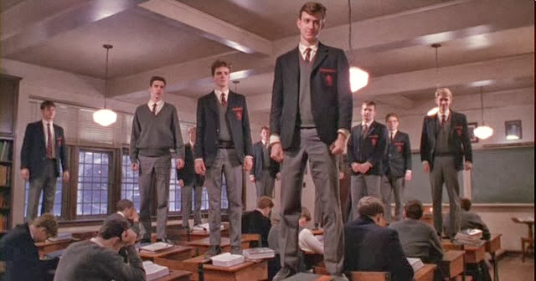
English 11
Response Journal #10 – Dead Poets Society
Painfully shy Todd Anderson has been sent to the school where his popular older brother was valedictorian. His room-mate, Neil, although exceedingly bright and popular, is very much under the thumb of his overbearing father. The two, along with their other friends, meet Professor Keating, their new English teacher, who tells them of the Dead Poets Society, and encourages them to go against the status quo.

Questions to consider:

- Mr. Keating has an almost incalculable influence on his students. In a mere few months he profoundly changed their lives. What are some examples of this influence?
- Why does Mr. Keating have such an influence on his students? Why do they so loyally follow this leader?
- One answer to the above question, and the primary reason we use this video case, is that Keating habitually encourages / affirms his students. (A) Why is that effective, (B) how is it connected to humility, and (C) what might be in the way of becoming this sort of encouraging leader?
- Contrast the leadership style of Mr. Keating with that of Mr. Nolan (the headmaster) and Mr. Perry (Neil’s dad). Both of these styles get results, don’t they? So why choose the former?
- What are the most important leadership lessons you have gleaned from this story?

- To what extent do parents today pressure their children to be successful?
- How do you feel about expressing your feelings to your parents? What types of ideas do you openly share? When is it difficult to confide in them?
- Is suicide an acceptable solution to anyone’s life problems? Explain.
- Why is the administration of Welton Academy so set on making their students conform to the “cookie-cutter” image of success and discipline?
- Why do you think Welton Academy is so anxious to hold Mr. Keating responsible for Neal’s death?
- Have you ever found it difficult to be your “true self” around others?
- If the setting of this movie were in a public school, instead of a prestigious academy, would the message be any different?
- What does the closing scene of the movie symbolize (when the students stood on their desks, crying “Oh captain, my captain…”)?

Note: While you do not need to respond to all questions, you should discuss a couple of the above points in a one page write as per the outline of the Response Journal Rubric.

