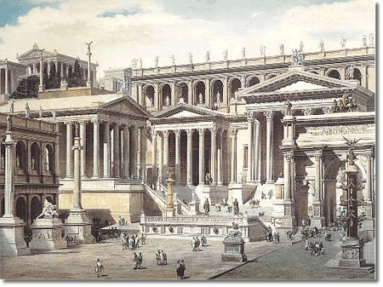
Name:
The Rise of Rome
References:
DeGeer & Newman, Odyssey Through the Ages, 1992
Class Notes
Questions

1. Discuss key features of Italian geography that influenced Rome as a power in the Mediterranean.

2. Who were the Etruscans? What influence did they have on the Romans?

3. Assess the story of Romulus and Remus as an ‘inspiration for Rome.’ What does it suggest is important and/or would be important as an origin story for a great empire? (See also, p. 266-67)

4. To what degree did the Roman constitution provide its citizens with equality and an effective government? Explain with consideration to the roles of assemblies and magistrates in the Republic.

5. What were the driving forces behind Rome’s desire to expand?

6. Who was Hannibal? Why was he not able to conquer Rome (the Peninsula) even in occupying it?

7. How did Rome’s conflicts with Carthage propel it into expansion across the Mediterranean World?

8. Social and political dissatisfaction were inherently a part of the Roman Republic. Explain. (p. 246-249)

9. The Republic was flailing (failing?) and out of it emerges the rise of powerful military leaders. Explain.

10. In your view of Rome’s political situation, was Caesar really a threat to the Republic? Discuss.

11. To what degree was Rome a male-dominated society? Discuss.

