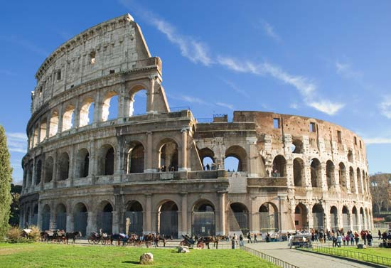
Name:
The Roman Empire
References:
DeGeer & Newman, Odyssey Through the Ages, 1992
Class Notes

1. To what degree can Augustus be credited with restoring peace and prosperity to Rome?

2. It has been said that architecture is an accurate reflection of the society which produced it? The pyramids of Egypt showed their devotion to their pharaohs and the degree to which they prepared for death. The Parthenon in Athens shows the mathematical precision of the ancient Greeks and their attention to perfect beauty. By examining some of the major buildings of ancient Rome what can we learn about its people? Explain using examples of buildings, architecture and other functional structures.

3. Explain why Christ was crucified and why, after his resurrection, Christianity became a popular sect in the Roman Empire.

4. Differentiate between Judaism and Christianity and identify the point in time at which Christianity ceased to be a Jewish sect.

5. How extensive a role did slavery play in the Roman Empire and how were enslaved people treated?

6. How were the Christians treated during the reign of Diocletian? Why?

7. Explain the difference between BC and AD (p. 289).
7. Discuss the Pantheon as an inspiration for future architects. Why so influential in the western world?

9. Despite living nearly half a century apart Livy and Tacitus shared a common concern. Identify this concern and explain how each, in their writings attempted to provide a guide for how Romans should live their lives.

10. For what is Constantine the Great best remembered?

11. What signs of decline were evident during the time of Diocletian and how successful were his attempts to prevent further decline?

Define
The Cult of Isis

Mithraism

12. Define Barbarian (in Rome). How did these ‘barbarians’ effect the Roman Empire?

13. Why did the Roman Empire in the west collapse?

14. What are the major legacies that we have inherited from the Romans?

