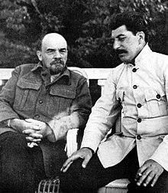
Name:
The Russian Revolution
References:
Student Workbook, p. 13-20
www.campbellswebsoup.weebly.com
- The Russian Revolution (slide show)

Questions:
1. Discuss the social and political problems in Russia pre-1917.
Vladimir Lenin & Josef Stalin (c. 1923)

2. Explain who Karl Marx is/was and what his critique of capitalism is/was.

3. What did Marx propose as a solution for the problems of capitalism?

4. The February (also known as the ‘March’) Revolution was ‘leaderless and spontaneous.’ Explain.

5. The Provisional Government that followed the Tsar became unpopular amongst the people – why?

6. What was the meaning of Lenin’s slogan, ‘Peace, Bread, and Land’?

7. The October Revolution was the second ‘revolution’ that occurred in 1917. Explain how it differed from the February (‘March’) Revolution.

Define
Treaty of Brest-Litovsk

Russian Civil War

Soviet Union in the Interwar Years (p. 1920)
8. Who succeeded Vladimir Lenin as leader of the Russian Communist Party (and USSR)?

Define
command economy

collectivization

gulag

Great Terror

9. Stalin was as much a builder of modern Russia as he was a destroyer of Russian society. Explain.

