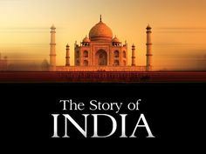
Name:
The Story of India
The Golden Age

Video/Discussion Questions:

The Story of Rama
1. Why do Indians consider the 5th century AD a golden age? How is India’s golden age similar to and different from other cultures’ golden ages?

2. What are the basic lessons to be gleaned from Rama and his stories?

3. How has Rama mythology been used by Hindu extremists?

The Gupta Empire
4. How did the Chinese traveler Fa Hsien describe the Gupta Empire? Why is his outside perspective important to historians?

5. What advancements in science and math did the Indians achieve during the Gupta empire era?

The Cholans
6. What does the Kama Sutra tell us about Indian gender relations?

7. In what way are the Cholans compared to the ancient Athenians?

8. How are aspects of the Cholan civilization still alive today?
Rajaraja
9. How is King Rajaraja thought about today by his descendants?

10. What are the modern implications of Rajaraja and Tamil culture?

11. How did the Cholans represent the Hindu gods artistically?

12. How did King Rajaraja and the Tamil represent Shiva? What is symbolic about this portrayal?

The Festival of Light
13. Why have Tamil culture and Cholan influences remained prominent in southern India?

14. Why did the Cholans build the Anicut Dam?

15. What role does food and cooking play in southern India?

16. Why are pilgrimages important in Indian life? What other religious pilgrimages can be found around the world? Is there the same frequency or number as in India? Why or why not?

