Exploring Themes in a Variety of Genres

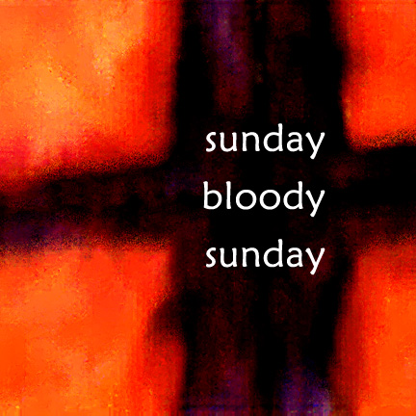
Sunday Bloody Sunday
U2
I can't believe the news today
Oh, I can't close my eyes and make it go away
How long, how long must we sing this song?
How long? How long?
'Cause tonight we can be as one, tonight
Broken bottles under children's feet
Bodies strewn across the dead end streets
But I won't heed the battle call
It puts my back up, puts my back up against the wall
Sunday, Bloody Sunday
Sunday, Bloody Sunday
Sunday, Bloody Sunday
“Bloody Sunday” Questions

1. What does this song seem to be about? Why do you think so?

2. What could the following lines indicate about the subject matter of the song?

- “How long, how long must we sing this song?
How long? How long?”
- “'Cause tonight we can be as one, tonight”
- “The trench is dug within our hearts
And mothers, children, brothers, sisters torn apart”

3. What are some of the theme topics being explored in the song? Why do you think so?

And the battle's just begun
There's many lost but tell me who has won
The trench is dug within our hearts
And mothers, children, brothers, sisters torn apart
Sunday, Bloody Sunday
Sunday, Bloody Sunday
How long, how long must we sing this song?
How long? How long?
'Cause tonight we can be as one
Tonight, tonight
Sunday, Bloody Sunday
Sunday, Bloody Sunday

Wipe the tears from your eyes
Wipe your tears away
Oh, wipe your tears away
Oh, wipe your tears away
Oh, wipe your blood shot eyes
Sunday, Bloody Sunday
Sunday, Bloody Sunday

And it's true we are immune when fact is fiction and TV reality
And today the millions cry
We eat and drink while tomorrow they die
The real battle just begun to claim the victory Jesus won on
Sunday Bloody Sunday
Sunday Bloody Sunday

“The Sniper” - Liam O’Flaherty

Group Discussion Questions

Instructions: These are to be answered on a separate sheet of paper in complete sentences. Each member of the group must have their OWN copy of the answers.

- What details does the author provide to identify the setting of the story in Paragraphs 1 & 2?

- Where does the climax in this story occur? What does it tell you about the author’s purpose in writing this story?

- Explain what kind of irony is found in the last sentence of the story: “Then the sniper turned over the dead boy and looked into his brother’s face.” Is this irony effective or melodramatic? Explain.

- In addition to mystery, O’Flaherty also uses dilemma to create suspense. Describe the dilemma in “The Sniper”.

- This story takes place in the 1920s, during the Irish Civil War. How does the author’s use of “in medias res” (in the middle of things) give this piece a timeless quality, however?

- Read the poem “Conflict” below. What similar theme and subject-matter do both “Conflict and “The Sniper” illustrate? Write a theme statement – and remember your theme should be one-two sentences long and should not be a moral but a statement of a universal truth. What similarities do they share with “Bloody Sunday” as well?

“Conflict” by F.R. Scott

When I see the falling bombs
Then I see defended homes.
Men above and men below
Die to save the good they know.

Through the wrong the bullets prove
Shows the bravery of love.
Pro and con have single stem
Half a truth dividing them.

Between the dagger and the breast
The bond is stronger than the beast.
Prison, ghetto, flag and gun
Mark the craving for the One.

Persecution’s cruel mouth
Shows a twisted love truth.
Deeper than the rack and rope
Lies the double human hope.

My good, your good, good we seek
Though we turn no other cheek.
He who slays and he who’s slain
Like in purpose, like in pain.

Who shall bend to single plan
The narrow sacrifice of man?
Find the central human urge
To make a thousand roads converge?
Historical Background of “The Sniper”

Northern Ireland came into existence with the British Government of Ireland Act (1920) which divided Ireland into two areas: the Irish Free State, made up of the 26 southern counties in the South, and Northern Ireland - comprising 6 counties. Roman Catholics, who made up around one-third of the population of Northern Ireland, were largely opposed to the partition. Formed in 1969 as the clandestine armed wing of the political movement Sinn Fein, the IRA (Irish Republican Army) is devoted both to removing British forces from Northern Ireland and to unifying Ireland.
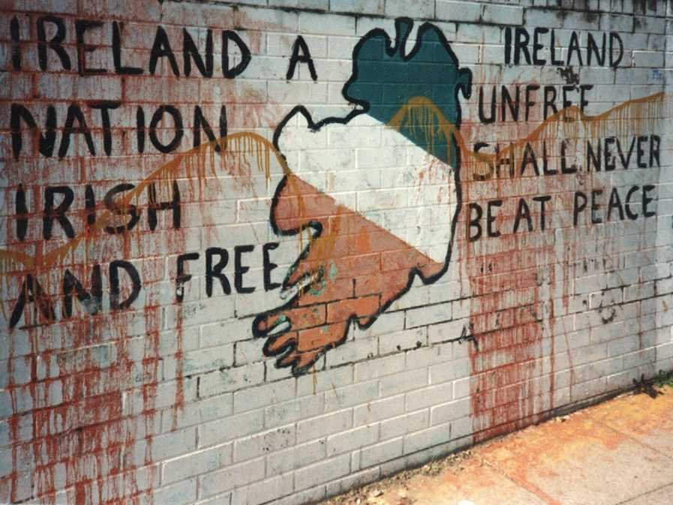
In 1919, the newly formed Irish Republican Army (IRA) launched guerilla warfare during the Irish War of Independence to liberate Ireland from the British. Unable to contain the rebels, London agreed in the 1921 Anglo-Irish Treaty to create an Irish Free State. However, the agreement would recognize the Free State only as a dominion in the British Commonwealth of Nations. Moreover, it would permit six counties in northern Ireland to withdraw from the Free State, allow the British to maintain ports in the south, and require the Free State to pay part of the debt Britain incurred in waging the war. Consequently, not all Irishmen accepted the agreement, the provisions of which became effective in 1922. (The six northern counties seceded (or withdrew formally from membership in the federal union with Britain), as expected.) Once-united Irish fighters were now split into two factions—disgruntled IRA members and supporters of the Free State—and fought a civil war. O’Flaherty, himself a member of the IRA, centers his short story on a scene of fighting in Dublin in which an IRA sniper shoots at Free Staters from a rooftop.

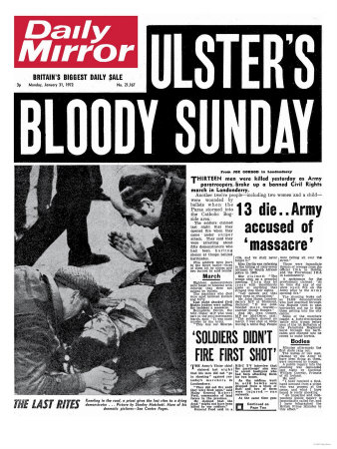
Historical Background to “Sunday Bloody Sunday”
"Sunday Bloody Sunday" is noted for its militaristic drumbeat, harsh guitar, and melodic harmonies. One of U2's most overtly political songs, its lyrics describe the horror felt by an observer of the Troubles in Northern Ireland, mainly focusing on the Bloody Sunday incident in Derry in 1972 where British troops shot and killed unarmed civil rights protesters and bystanders who were there to rally against internment (imprisonment without trial).
The Troubles is the common name for the ethno-nationalist conflict in Northern Ireland that spilled over at various times into the Republic of Ireland, England and mainland Europe. The Troubles began in the late 1960s and is deemed by many to have ended with the Belfast 'Good Friday' Agreement of 1998, but sporadic violence has continued since then. Internationally, the Troubles is also commonly called the Northern Ireland conflict and has often been described as a war.
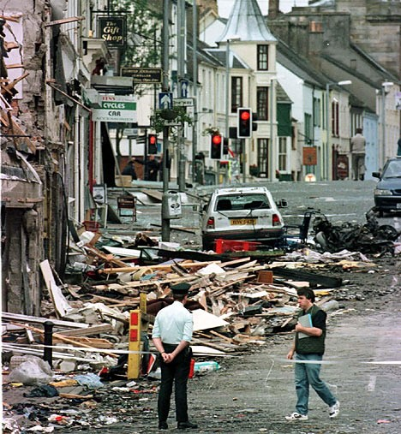
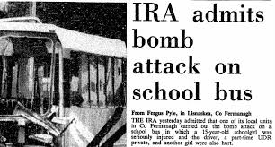
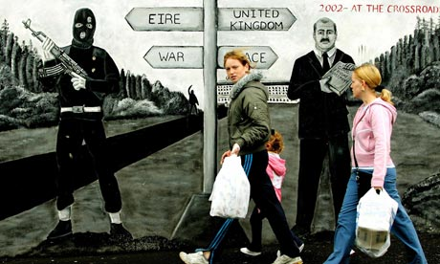
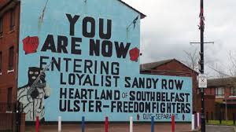
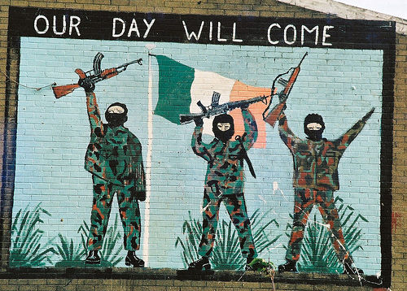
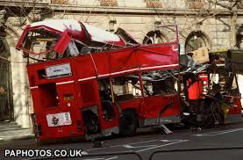
Traditional IRA activities have included bombings, assassinations, kidnappings, punishment beatings, extortion, smuggling, and robberies. Before the cease-fire in 1997, the group had conducted bombing campaigns on various targets in Northern Ireland and Great Britain, including senior British Government officials, civilians, police, and British military targets.
Aftermath of IRA bombings in Britain
Graffiti / Wall Art in Northern Ireland

