20th Century History
Vietnam
Reference: Global Forces of the Twentieth Century, Chpt. 13 (p. 238-244)
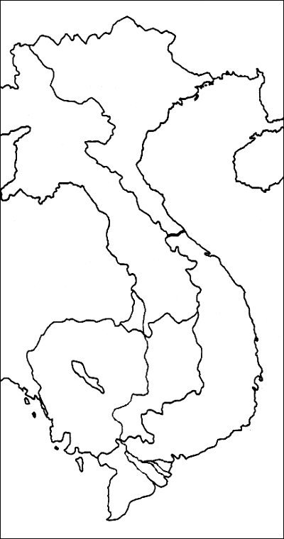
Class Notes/Discussion/Lecture/Handouts

Map of French Indo-China (p.238)

Label:
- North Vietnam
- South Vietnam
- Laos
- Cambodia
- Thailand

- Dien Bien Phu
- Hanoi
- Saigon
- Hue

- Mekong River
- Mekong Delta
- Gulf of Tonkin

Questions
1. Explain the French position and involvement in Indo-China.

2. In what ways does the Korean War affect the Vietnam War?

3. What is the significance of the Battle of Dien Bien Phu? For the French? The Viet Minh? The Americans?

4. What was the Ho Chi Minh Trail? What countries does it traverse? Significance?

5. Explain America’s ‘Domino Theory” in the context of Asia.

6. What was the aim of Ho Chi Minh and his followers? Why did the USA not recognize Ho Chi Minh’s government?

7. Evaluate the government of South Vietnam led by Ngo Dinh Diem. Why was his leadership problematic?

8. Who were the Viet Cong? What role do they play in South Vietnam? They were a ‘guerilla force.’ Explain.

9. What was the Gulf of Tonkin Incident in 1964? Explain its significance.

10. What happened during the Tet Offensive?

11. What American President (1968) promised to take the USA out of the Vietnam War? _____________________

12. In a paragraph explain what was achieved by fighting in Vietnam. For the Vietnamese? For the Americans?

