Social Studies 11 Explorations
Turning Points of WWII: Themes and Theatres of War

Instructions:
- Select 12 events/themes from the list provided (see backside).
- A detailed paragraph description for each event must be provided. This description must include an explanation of why that particular event or theme is a turning point and how the event/theme is important in the context of the entire war.
- A visual must also be provided for each event/theme one is reviewing. The visual can be of a map, a photograph, a poster, an artist’s rendering (et cetera) of the event/theme in question. A brief description (1-2 sentences) (this is called a caption) of the visual underneath the image is required, as is a citation (Chicago Style) that indicates the source (where you found the image – website, etc.

- Your assignment must include:
  - Minimum of one event regarding the pre-War years
  - Minimum of one event regarding the War in Asia
  - Minimum of one event regarding the War in the Pacific
  - Minimum of one event regarding the War in Africa
  - Minimum of two themes seen throughout the War
            - see list on reverse side of this page

- Write a rationale - one paragraph, for each event/theme selected. See example that follows.
- Format your image and description in an organized manner. One may choose to use google docs or slides (or word or power point) for the organizing this assignment.

Blitzkrieg
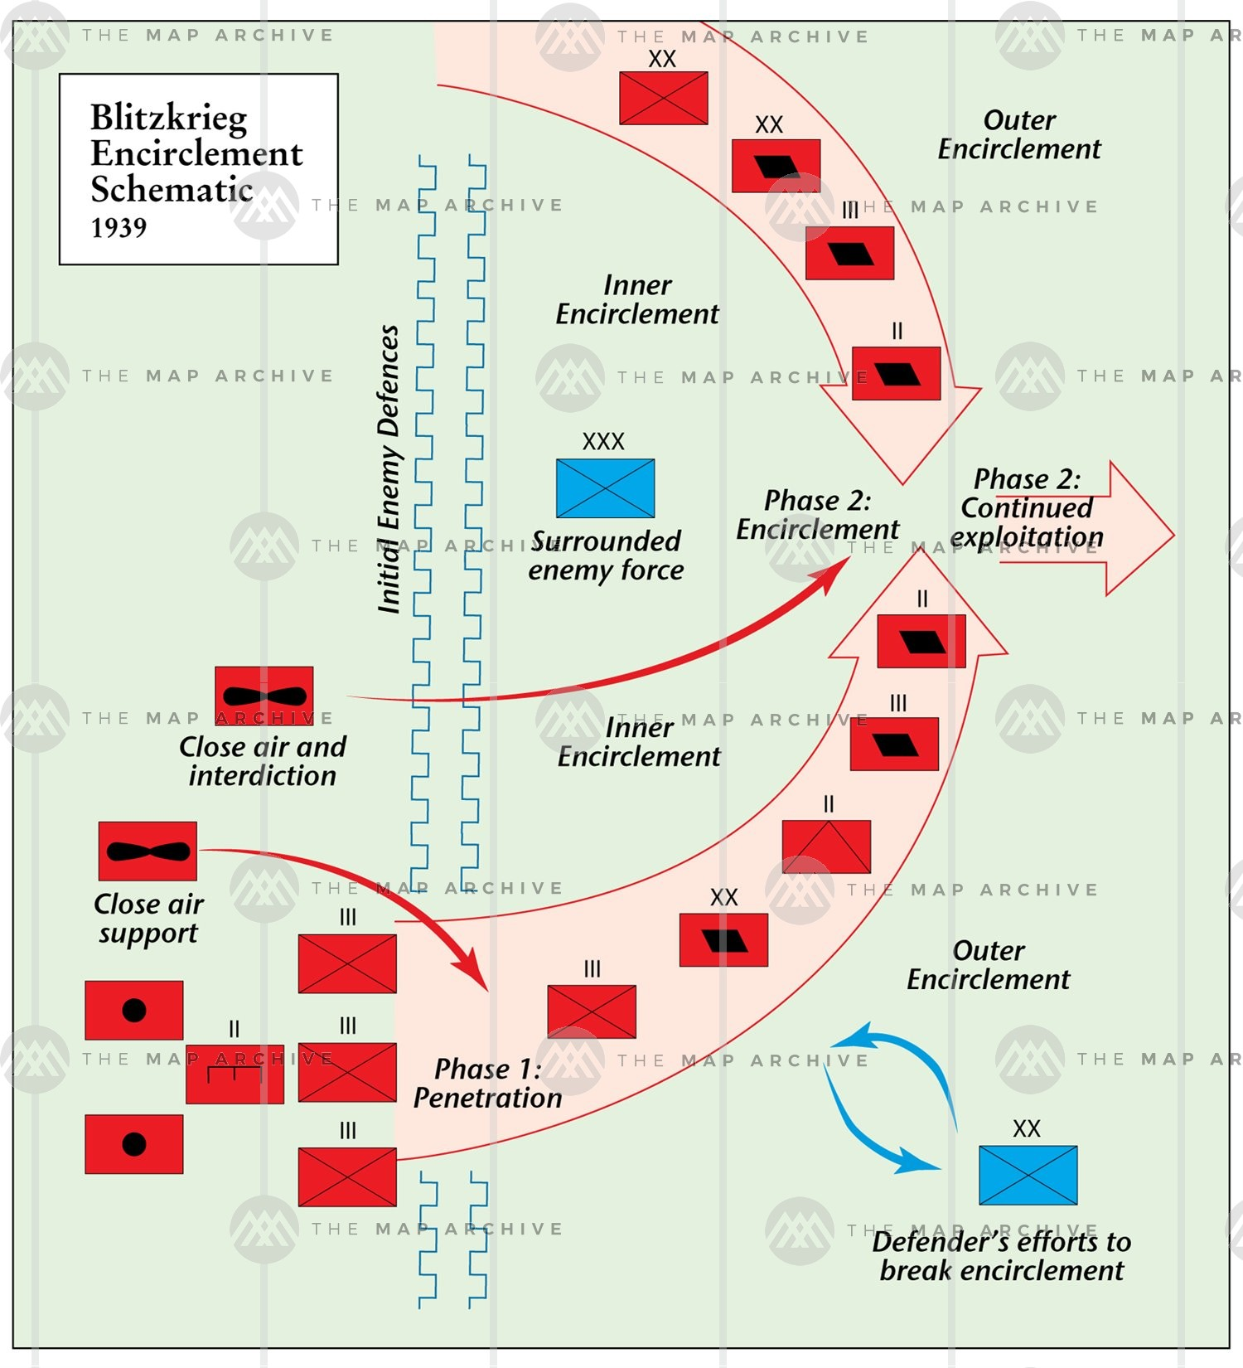
Blitzkrieg is a German military strategy utilized in WWII to quickly overwhelm enemies through the use of mobile units (tanks) and air support. The German invasion of Poland in 1939, and subsequent invasions of Norway, Denmark, the Netherlands, and Belgium illustrate blitzkrieg, as the Nazi army rapidly swept through much of Europe. Blitzkrieg allowed the German army to take control of massive areas of Europe before enemy forces could mobilize, giving the Germans a tremendous advantage. This tactic illustrated a different approach by the German military in a major European conflict in an effort to avoid the stalemate that characterized World War I. It was chiefly responsible for the early success of the German assault on Europe, though its success would be negated by multiple factors following 1942.
An illustration of the blitzkrieg tactic used by the German Wehrmacht in the early going of World War II.
Sources:
The Map Archive. 2020. “The Blitzkrieg Encirclement, 1939.” Accessed March 30th, 2020.
https://www.themaparchive.com/blitzkrieg-encirclement-1939.html
Foley, Robert T. 2011. “Blitzkrieg.” BBC. Accessed March 30th, 2020
http://www.bbc.co.uk/history/worldwars/wwtwo/blitzkrieg_01.shtml

- Read the textbooks and use other sources such as: the Internet, books, the library, campbellswebsoup.weebly.com, etc., to research your chosen events.
- It is recommended that you look beyond Wikipedia for information on the topics you are researching. The Reynolds Library Website has good research ‘toolkit,’ with the likes of Canadian Encyclopedia and World Book Online.
- Provide citations beneath each entry (event/theme using Chicago Author-Date Style)
- Conference with your teacher. Ask for help, ask questions, and have your work checked.
Please be sure to submit a polished work on the due date – April, 15th, 2020.
Assessment
- Visuals (2)
  - relevance of imagery/caption
  - citation
- Paragraph Description (3)
  - Context – relevance to war effort?
  - rationale – why important?

Possible Events/ Turning Points/ Themes

Pre-War
Japanese Invasion of Manchuria
Italian Invasion of Abyssinia
Spanish Civil War
Nazi-Soviet Non-Aggression Pact

War in Asia
Sino-Japanese War
Rape of Nanking
Battle of Hong Kong
Burma (the forgotten front)

War in the Pacific
Pearl Harbour
Battle of Midway
Battle of Coral Sea
Battle of Leyte Gulf
Battle of Guadalcanal
Battle of Iwo Jima & Okinawa
Hiroshima & Nagasaki

War in Russia
Operation Barbarossa
Kiev Offensive
Siege of Leningrad
Battle of Moscow
Battle of Stalingrad

War in Europe
Russo-Finish War
Invasion of Poland
Fall of France
Battle of the Atlantic
Battle of Britain
Balkans Campaign
Bomber Command/Offensive
Normandy Invasion (D-Day)
Italian Campaign
Battle of the Bulge
Warsaw Uprising

War in Africa
Desert War
Siege of Tobruk
Battle of El Alamein
Operation Torch
Tunisia Campaign

Themes
Appeasement
Lebensraum
Blitzkrieg
Maginot Line
‘Strategic Bombing’
Resistance Movements
Genocide
Kamikaze
Tanks or Airplanes
Aircraft Carriers
Women in War
Island Hopping

Note: If there is another event/ theme you are interested in reviewing, see your teacher for confirmation before pursuing.

